**Section Introduction**  
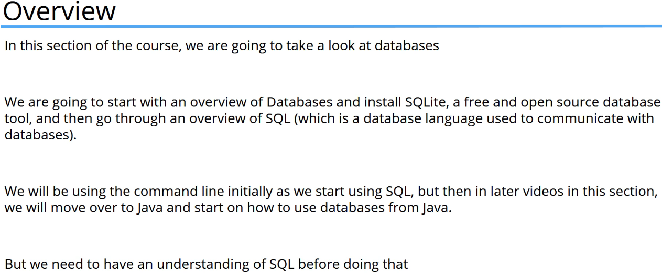

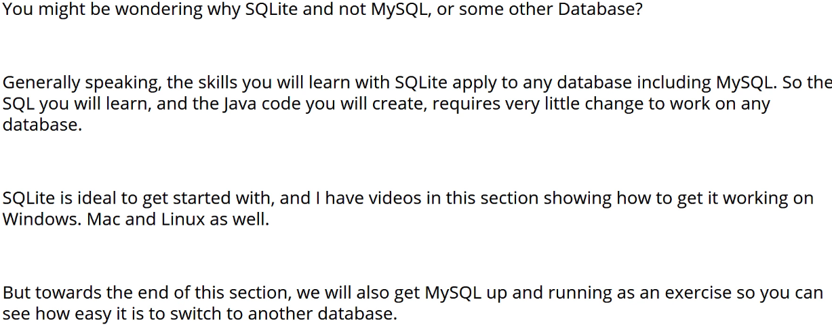  
* **It’s also one of the most highly used programs in the world**.

**Database Terminology**  
* **Database** => the container for all the data that you store or that resides inside. When you use the term Database, you’re referring to the entire data as well as the structure it’s stored in and in addition any queries and views on that data.  
* In SQLite, the entire database contents are stored in 1 single file. But that isn’t true of most large database systems.  
* **Database** **Dictionary** => provides a comprehensive list of the structures and types of data that are used in recording the data. So basically it descrives all the tables and fields within the database.  
* In SQLite there is a table in each database called SQL_lite_master that has this information in it. You can query that table but there are commands that do it for you so you don’t have to understand the structure of the master table.  
* **Table** => a collection of related data held in a database.   
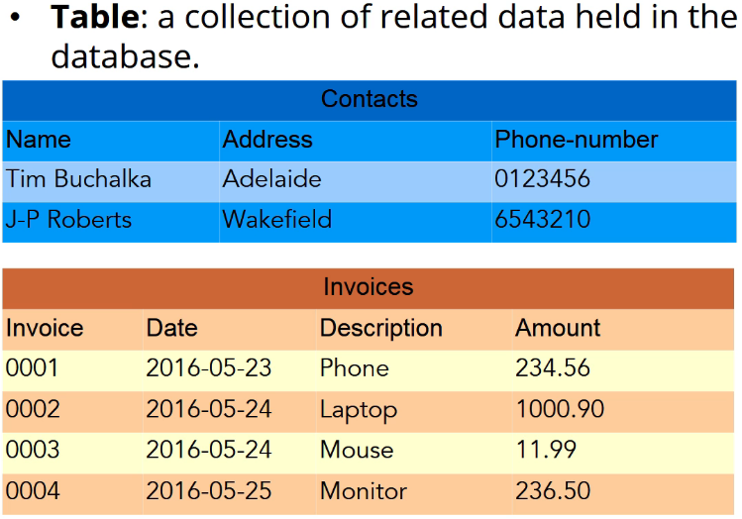  
* Think of a contact database for example that stores the name, the address, and the phone mumber, or perhaps your customers. Or what about an invoice table that records the invoice number and details of the invoice.  
* SQLite or another database like Microsoft SQL server are ideal for storing structured data that can be organized neatly into rows and columns.  
* With all the interest in Big Data, there are now databases such as NoSQL or Hadoop that can cope with data that doesn’t have such an obvious structure. But we’re going to be restricting our use of database to structured data.  
* **Field** => the basic unit of data in a table.  
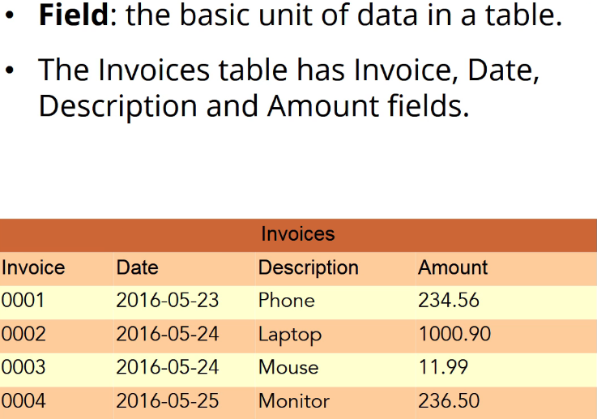  
* Field in a database can be thought of probably in a similar way to what a variable is.  
=> Just like a class variable, a **database field has a NAME + TYPE**.  
* Many databases also allow date fields, large text fields, and also fields where you can store things like photographs or audio. These field types are often called **BLOB**s which is supposed to stand for **Binary Large Object**.  
* **Column** => **another name for field**.  
* In a spreadsheet, the term column refers to the entire set of data extending across many rows.  
=> But in a relational database, column generally refers to a single entry. Although when talking about the structure of a table rather than the actual data, then you could talk about a column to hold the invoice number which is probably closer to the spreadsheet use of the term.

* When refering to the data in the database though, we’re talking about an individual item like a base unit of data.  
* **Row** / **Record** => is a single set of data for all fields that are in that table.  
* So it’s really a collection of all the columns that comprise the details of one entry in that table.  
* The correct database terminology is actually **ROW**.  
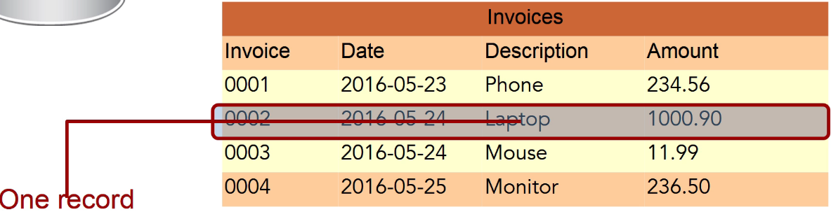  
* **Flat File database** => stores all the data in a single file which can result in **a lot of duplication** of data and **makes updates difficult**.  
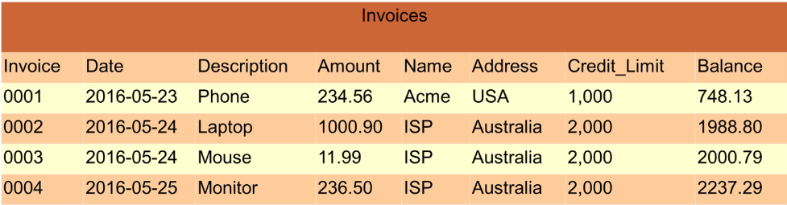  
* Every row in the table that contains a record for ISP, must be changed in order to increase the credit limit. These databases aren’t used very often anymore but they were fairly popular in the early days as they directly mapped to those card index records that companies sometimes used.  
* If we were storing names, addresses and phone number information, then a Flat File database is fine for the job and even today people still use address books and rolex style contact systems with each person’s details on a different car.  
* Using a Relational Database, tables can be related to other tables which is very useful.  
=> We can split the data out into a customer table which contains standard company data such as their name, address and a credit limit. And another table containing all that customers’ purchases.  
=> The name column in the customer table is related to the name column in the invoices table.  
=> In relational database terms this is called a JOIN. In this example we have a ONE-TO-MANY join because there can and probably will be many invoice rows for each customer.  
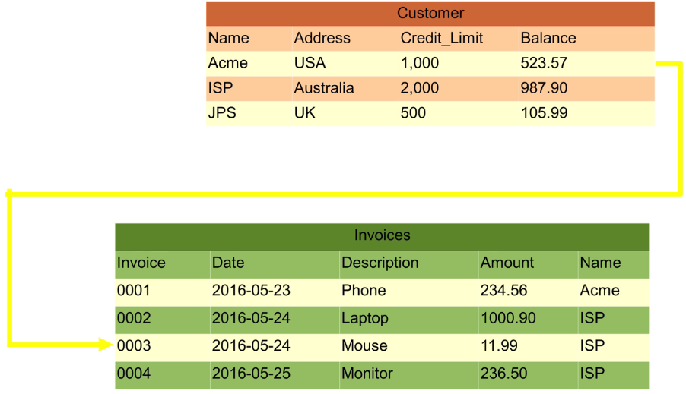  
* Using a relational model, updating a customer’s credit limit involves changing the data in just a single row.

* You’ll often see designs where a 3rd table is used to provide the link:  
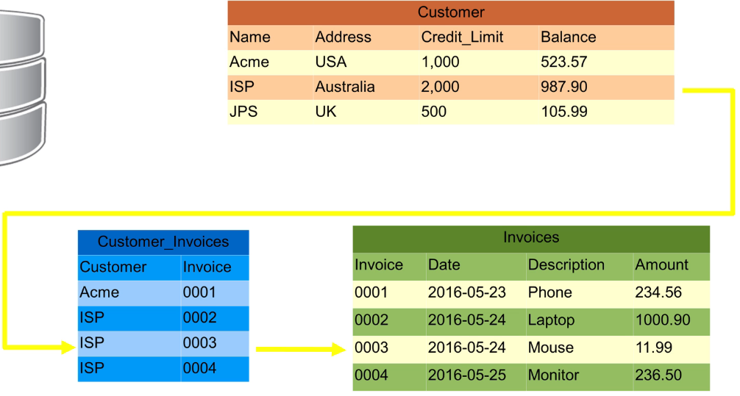  
* It’s also very common to use a linking table to relate the data to two other tables.  
* Here when an invoice record is stored, a new record is created in the customer_invoices table to link for example invoice 0004 with customer ISP.  
=> One advantage of this is that the invoice table only contains data relating to invoices. The rows aren’t cluttered up with any customer information, not even the name.  
* **Normalization** => splitting the data up like this is known as normalization. Database normalization is basically the process of removing redundant duplicated and irrelevant data from the tables and the more that this is done, the higher the level of normalization.  
* You can go up to level 6 normal form.  
* But in most practical applications, it’s rare to go beyond the 3rd level.  
* It’s an interesting subject but the math can get a bit horrible at the high levels.  
* Our example on the slide isn’t quite as normal as it should be because we’ve used the customer name as the link between the customer and invoice tables. If one of our customers changes his name, which is quite a common thing to happen, then we’ll have to update each of the relevant entries in the customer_invoices table as well.  
=> The usual way to deal with this is to use a unique ID field that stays the same for each customer once it’s allocated.  
=> We shouldn’t store the customer balances in the table as that’s best calculated when needed.  
* **View** => a selection of rows and columns, possible from more than one table.  
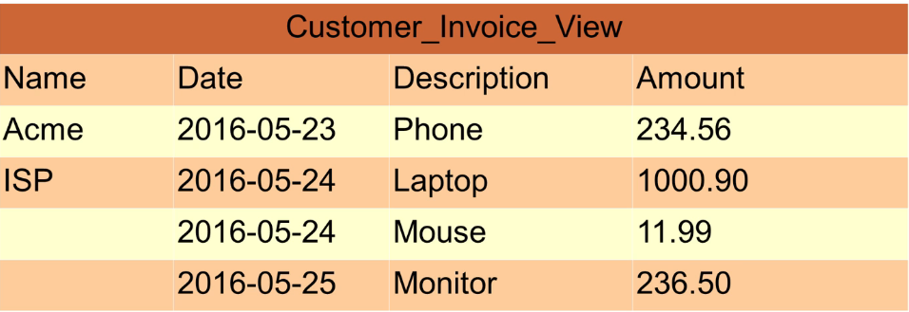  
* Here it contains columns from the customer table and the invoices table. So a View can contain just some columns from a single table for example just the description column from the invoice table to produce a list of items that have been sold.  
* In sqlite the data in the view can’t be updated so that means that you can’t add a new row to a view and have it place the new data into the relevant tables.  
* Some databases such as Microsoft SQL Server do allow this but in that case the views have restrictions on the columns that can and must contain.  
* SQLite is designed to be embedded in applications and is actually a library that’s called from our application code.  
* It does ship with a shell program that you can use to create databases and integrate them though.

**Install and Setup SQLite for Windows**  
* The thing to keep in mind here is that writing database code straightaway isn’t the easiest way to learn about SQLite and the SQL language so.  
* If you get errors, you have to work out if it’s the errors in your code or in the SQL statement that you’ve used.  
=> So we’re going to start by installing the SQLite command line shell so that we can create databases and use SQL commands without having to worry about code yet.  
* On Windows the SQLite command line shell is an executable file called **SQLite 3**.  
=> **www.sqlite.org** => Download => the file we want is a bundled up command line tools for managing sqlite databases.  
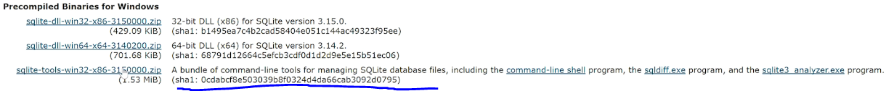  
* The description includes links to 3 executables:  
=> command-line shell  
=> sqldiff.exe  
=> sqlite3 analyzer.exe  
* You can check those links out in the future.  
* The tool we need at the moment is the command-line shell so what we need to do is extract the **contents of the zip file to a suitable directory** and then **add that directory to our path**.  
* Extract the zip somewhere, click on the name in the path and Right-click and copy address:  
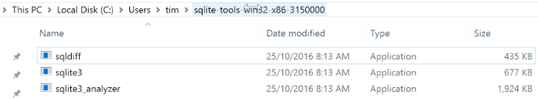  
* That’s going to take a copy of the path which we can use to update the path on our computer.  
* The instructions to set the path start off slightly differently depending on which version of windows you’re using.  
* I’m using Windows 10.  
=> If your keyboard has the Windows key, the quickest way for all versions of windows is to use windows and pause. So hold down the windows key and press pause. Otherwise you just need to navigate to the control panel => system and security => system.  
=> Advanced system settings  
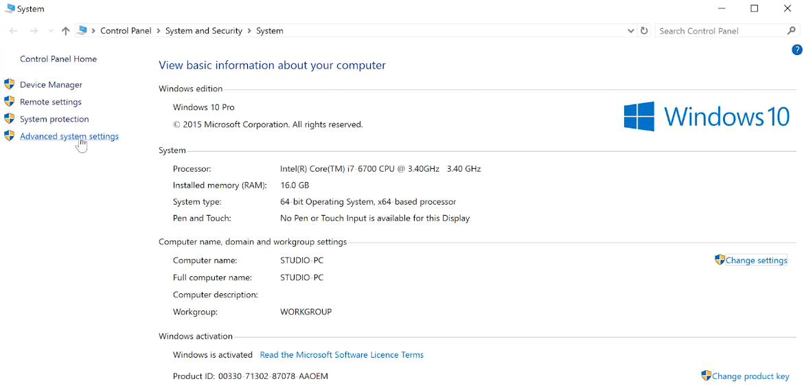  
* You can also right-click the My Computer icon and choose Properties.  
=> Environment Variables…  
* Unless you’re really comfortable with doing this, leave the System variables section alone, if you mess up the system path variables, it can be really quite difficult to recover windows.  
=> Under the user variables there might already be PATH variable. If not, you can click on NEW and specify the name: PATH and then you paste in the value.  
=> PATH (select it if it’s not)  
=> Edit…  
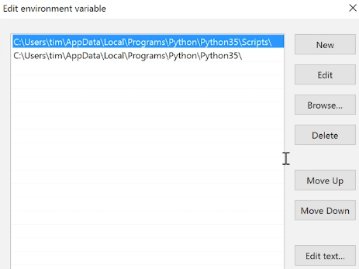  
* This is showing a new path variable being created on Windows 10. If you’re editing the existing path variable leave the name unchanged and just add a ; to the end of the previous value.  
=> On Windows 10 => New => paste in the value there.  
* Now let’s check if it’s working:  
**=> CMD => sqlite3 => .quit**

**Install and Setup SQLite for Mac**  
* On a Mac it turns out this is really really easy and that’s because the sqlite command line shell is already installed on a Mac.  
**=> CMD + SPACE and type Terminal to open a terminal session => sqlite3 => .quit**

**Install and Setup SQLite for Linux**  
* On Ubuntu and Linux it turns out this is really easy.  
**=> open a terminal session => sudo apt install sqlite3 => sqlite3 => .quit**

**Introduction to SQLite**  
* We’ll be using SQLite in our programs later but for now we’re just going to focus on the SQL language so that we can concentrate on learning a bit about SQL without worrying about the Java side of things.  
* Start a terminal sessions or command prompt on your computer.  
**sqlite3** => start  
**sqlite3 test.db** => also specify the name of the database on the command line  
* There is a command to open a database file if you forget to put the name on the command line, we’ll look at that later.  
**.quit** => exit  
* You will find that this sqlite program is a fairly minimal interface that just really tells us the version of sqlite that we’re using and that we can use:  
**.help** => **to get a lit of available commands**  
* We can also enter SQL statements and with some versions there’s also a helpful reminder that **SQL statements must be terminated with a semi colon**.  
* Before creating a new table in the database, you want to type in  
**.headers on** => this shows the column names at the start of the data which is a handy reminder of what we called the columns.  
* When creating and querying tables, we use SQL statements.  
* Let’s create a simple contacts table.  
**CREATE TABLE contacts (name text, phone integer, email text);**  
**INSERT INTO contacts (field, field, field) VALUES (‘text’, 123, ‘text’);**  
* **You can use single or double quotes.**  
**=> If you’re embedding SQL commands in Java, it makes sense to use double quotes for the strings and single quotes around the SQL statements**.  
* Type examples: text, integer.  
* I’m going to type the SQL reserved words in capitals and it’s useful to do that especially in programs and scripts. People generally just do it to make it obvious which are the SQL reserved words and which are things like tables and column names.  
**SELECT * FROM contacts;**  
**SELECT name, phone, email FROM contacts;**  
* You can add other clauses after SELECT and it’s nice to be able to split them on 2 different lines to make it more readable so sqlite will keep letting you type an SQL command and won’t try to execute it until you type the semicolon.  
**INSERT INTO contacts VALUES (“Brian”, 1234, ‘”brian@myemail.com”);**  
=> Because we’re providing values for all the fields and giving them in the order that the fields were defined in the table, there’s no need in this case to specify the list of fields.  
* **We shouldn’t store the phone number in an integer column, I just did that to show you how you can specify the type of columns when you create the table, a phone number is really best stored as a text field**.

* **SQLite doesn’t actually have type for its fields. It’s strange in that respect. Although you specify a type when defining the columns, that’s really just what you intend to put into them and in fact because the SQLite implement standard SQL, it has to use that standard form for creating tables where the columns have a data type**.  
=> **You can actually put any kind of data into any column**.

**More with SQLite**  
* **Make sure you use appropriate type for the columns when you’re creating tables because your code and the main client server SQL databases do actually check the type of data**.  
* One thing that SQLite lacks is an alter table command for changing things like the type of the columns. There’s ways around that - creating a new table and moving the data from the old table into it for example but it’s relaly best to get it right first time.  
**.backup testbackup** => if you don’t tell it what database to backup, then it’s going to backup the current one. This is a sqlite command, not a SQL statement.  
**UPDATE contacts SET email=”steve@hisemail.com”;**  
=> You have to be careful with this command, I haven’t at the moment told it which row to update, so it’s gonna update every row in the table.  
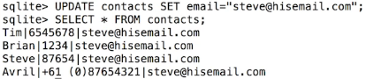  
* **.restore testbackup**  
**UPDATE contacts SET email=”steve@hisemail.com” WHERE name = “Steve”;**\* WHERE followed by a condition that identifies a row or a set of rows to be updated.  
**SELECT phone, email FROM contacts WHERE name=”Brian”;**  
* You can also delete, you have to be very careful again, deletes a whole row.  
**DELETE FROM contacts WHERE phone=1234;**  
* We’ve now seen a few SQL statements:  
**CREATE  
INSERT  
SELECT  
UPDATE  
DELETE**  
=> These are the most common commands that you need and you can do a lot with SQL databases with just those commands.  
* There are a few ways to modify the commands, especially the SELECT statement and we’ll be having a look at using JOIN in the next video to relate tables together.  
* Working with sqlite from the command line like this is very useful because you can concentrate on the details of your tables and columns and get everything right before trying to include the command in code.  
* It gets better too because there’s a couple of sqlite commands that you can use once everything’s set up.  
**.tables** => lists all the tables in the database.  
**.schema** => print out the structure of the tables, shows the SQL command that was used to create it.  
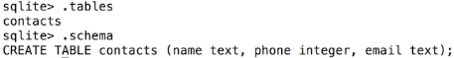  
* You can copy that command and paste it into your code when you want to create tables in code.  
* When you’ve got several tables, then:  
**.schema name** => will print the structure for just that one table.  
**.dump** => that not only gives you the SQL statement for creating the table, but all the INSERTs necessary to populate it with the data that’s in it. So it wraps the whole thing in what’s called a transaction.  
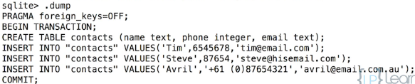  
* You can see we’ve got the BEGIN TRANSACTION and COMMIT there.  
**.exit** => will exit the sqlite shell and take you back to your command prompt or terminal session.  
* **The sqlite shell is useful when you need to design your database and it’s generally easier to use some sort of front end to database when setting things up so that you can make sure you’ve got all the tables created correctly with the right columns and so on**.  
* **You can also test the queries that you’ll be using in your code before you get around to writing the code so that you know that the SQL side of things has been set up correctly and is working ok**.

**Querying Data With SQL**  
* Let’s navigate to the folder where our music.db is located and use sqlite3 music.db.  
* **SQLite doesn’t care how you name your files, it’s common to name it .db or .sqlite though. It’s a good idea to avoid using .sql as that’s used to indicate that the file contains a SQL script**.  
  
* Some Java classes that handle database require an ID column called _id so it’s probably a good habit to get into.  
* Album:  
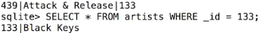  
* Song: `Permanent Vacation` is the 10th track in album 367:  


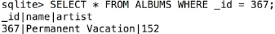  
* The ID field can be used to relate the songs and albums tables so we can easily see which album the song belongs to.  
**PRIMARY KEY** => a key in a table is an index which provides a way to really speed up searches and joins on a column. When columns are indexed, they can be searched much faster than if they’re not. Basically index columns are sorted so that they can be searched through much faster.  
* **In relational databases the ordering of the rows is undefined**. They’re very similar to Java Maps or Sets in that respect.  
* In fact, relational database theory is heavily based on Set theory.  
* By defining a key, you’re saying that the data should be ordered on that column or group of columns and searches etc. work far more efficiently as a result of doing that.  
* **There can be lots of keys on a table but there can only be 1 PRIMARY KEY**. Usually this is the _id.  
=> The PRIMARY KEY **must be unique**.  
* If we try to add another artist and use an ID that’s already in there, it fails.  
* Keys don’t have to be unique and often you’ll want to index a column that doesn’t have a unique value.

* A surname column in our database for example would benefit from being indexed but many people can have the same surname.  
**NOT NULL** => the column must contain a value.  
* **Primary Key is automatically NOT NULL because INTEGER PRIMARY KEY columns in SQLite are treated in a special way**.  
  
=> **The _id is automatically generated**.  
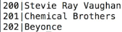  
* **This is slightly different from the behavior of other SQL databases such as Microsoft SQL Server where you have to specify autoincrement when creating a column if you want the values to be automatically generated**.

**SQL Order by and Joins**  
* When we use SELECT * we always get them in the same order - by the PRIMARY KEY.  
**ORDER BY**  
  
**COLLATE NOCASE** => ignore case  
**ASC** => ascending order **DESC** => descending order  
  
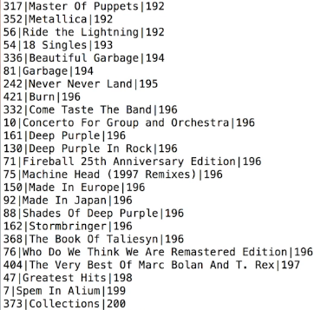

  
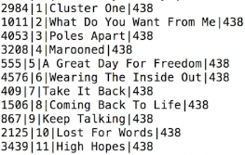  
  
* Let’s now join 2 tables together:  
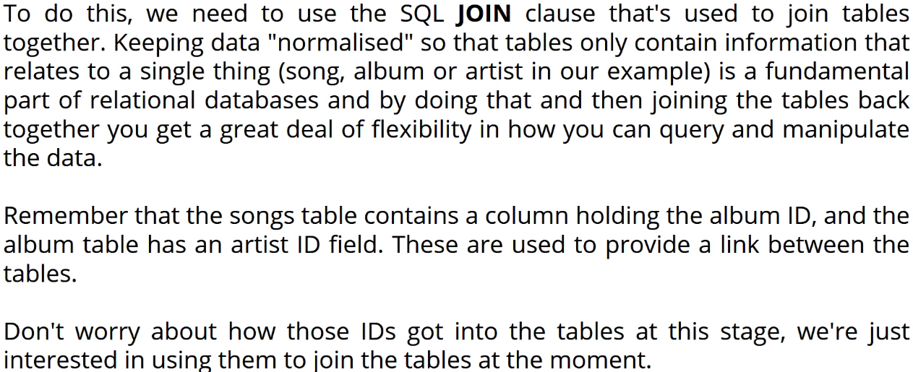

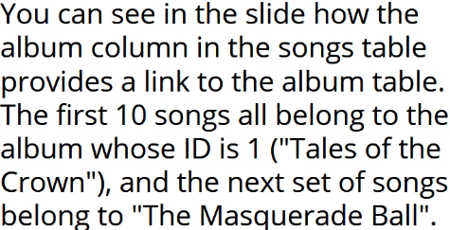

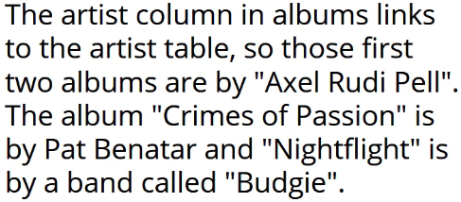  
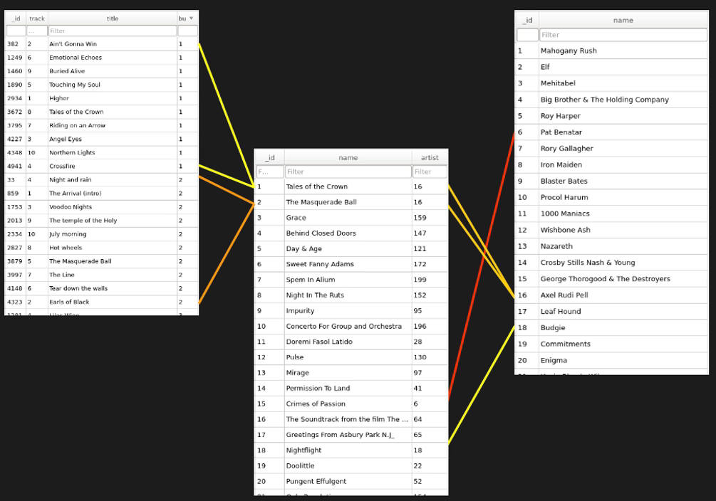  
**JOIN ON** => **Shorthand for INNER JOIN**.  
=> **The ON part says relate the rows in songs to those in albums where the songs table’s album column equals the albums table’s _id**.  
  
* **If there’s no ambiguity, you don’t need to provide the table name to the column**.  
* **But it’s a good habit to always specify the table name, especially in code**.  
  
* There are different types of joins.  
* **INNER JOIN** => the most common join.  
  
* **Not all database systems will allow you to leave off the word INNER so it’s worth always using it**.  
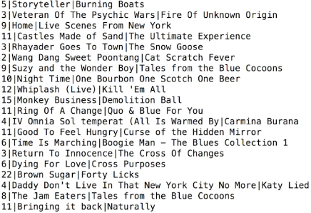  
* We can also add ORDER BY albums.name, songs.track:  
  
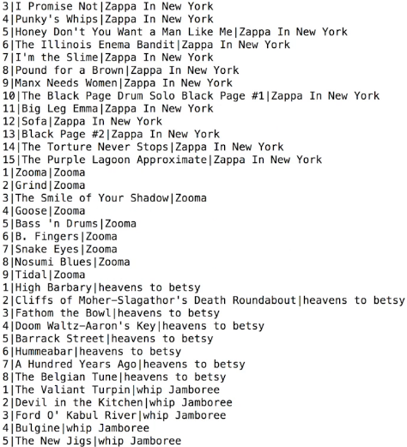

**More Complex Joins**  
  
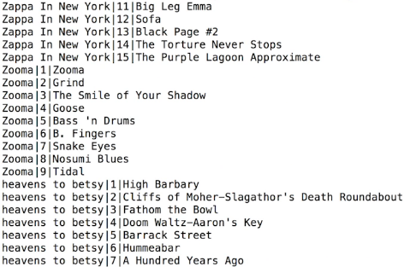  
* That does look much neater.  
  
* What if we wanted to find out which artist produced a song. The songs table doesn’t have any direct links to artists.  
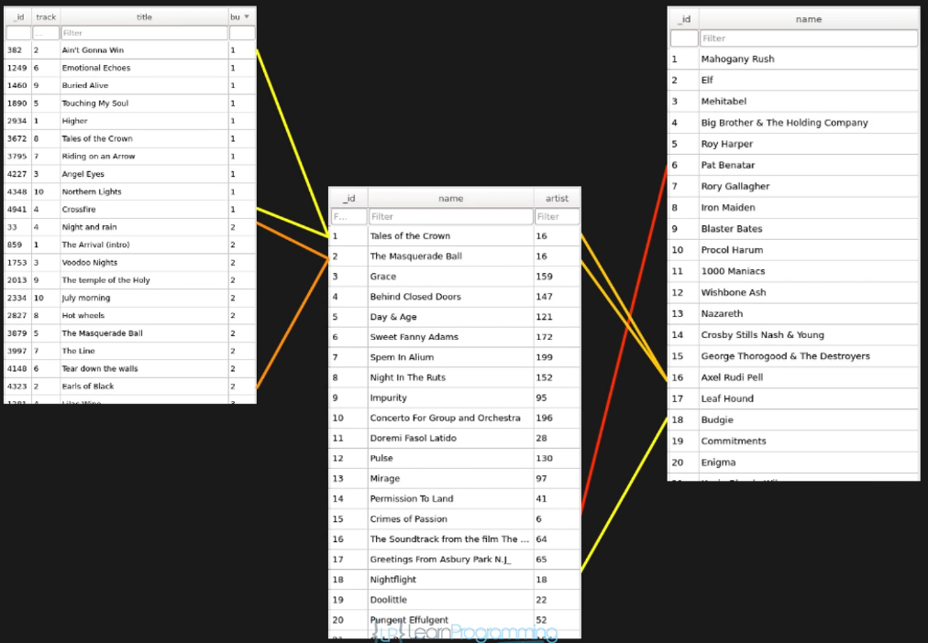  
* We can find out which album contains the song and from there find out who the artist is.  
=> We do that by JOINing songs to albums and then albums to artists.  
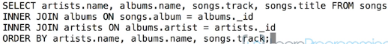

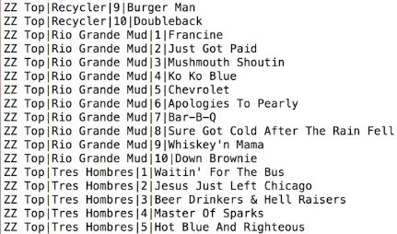  
* You can also nest SELECT inside another SELECT but if you get to the stage of needing to do that, then you’re really getting into more advanced SQL and that’s above what we have time to cover.  
* **Ordering of the clauses is important**.  
* **So you can’t go putting the ORDER BY clause before the JOINs for example. The order is strict in that regard so the order that we’ve been doing things so far is actually the correct way to do it**.  
* **WHERE clause has to go before the ORDER BY clause**.  
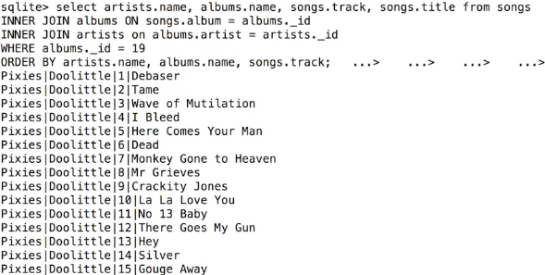  
* **The structure of the SELECT statement is quite straightforward:  
1) you specify the columns that you’re interested in,   
2) you JOIN any other tables that are needed,   
3) filter the selection using a WHERE clause and finally   
4) you order the results**.  
* You can have a text file open to help you with the copy/pasting between the two windows.  
* This is also useful when you’re working with code because you’ll be typing in a command interactively to make sure that it works.  
* That would normally be the sequence of things - you test to make sure that the queries, the SQL code that you’re typing is correct and valid in SQLite first and then once you’re sure it’s working, that’s when you copy the code and use it.

**Wildcards in Queries and Views**  
**Wildcard** => **LIKE** “**%**name%”  
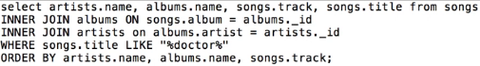  
* **LIKE is not case sensitive**.  
* You can use LIKE without a Wildcard to perform a search without worrying about the case.  
**_** => **match a single character**.  
* The major client server databases have what is known as **Stored Procedures** which are a way to store SQL queries amongst other things and execute them when you want. Often with parameters for things like the text to search for. They operate a little bit like functions or methods that are stored in the database and can be reused when you want.  
* Unfortunately, SQLite doesn’t have Stored Procedures, it’s a result of the fact that SQLite is intended to be embedded in programs.  
* Normal client-server SQL databases have the database server running on a remote machine that you connect to in order to access the data. A Stored Procedure runs on the server so it’s far more efficient than trying to work with a large data set on a remote machine. But as SQLite is not client-server and everything is running on the same machine anyway, the advantages of using Stored Procedures really don’t apply.  
* In addition, you don’t generally use SQLite interactively like we’re doing here.  
* What it does have is Views.  
**View** => A virtual table. It doesn’t really exist as a table but can be used as though it is one. You can’t modify data using a View at least not in SQLite, so you can’t UPDATE/DELETE/INSERT but you can query them just as if they were a table.  
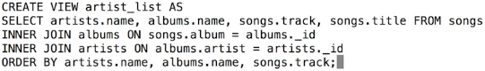

  
* You can use it just like any other table:  
  
* You can also create views on a single table and perhaps to restrict the columns that are returned or to show the records in a specified order without having to use the ORDER BY clause.  
=> **This can be a good way to include security in your application - the marketing department of a bank for example may need to know the contact details of customers so it can send out mail shops or emails but they shouldn’t have access to customer’s security questions or account details so a View could be used to provide them with the details they need while hiding the details that shouldn’t be made commonly available**.  
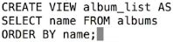  
**DROP VIEW**  
* Because of the clash, SQLite automatically renamed the name columns from the albums table to be name:1.  
  
* Not all database systems do this and it’s a good idea to explicitly name the columns when you create the View if there’s going to be a potential name clash.

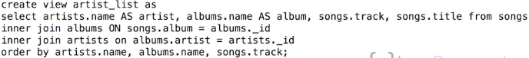

**Housekeeping and Final SQL Challenge**  
* SQL uses **<>** for not equal to. It avoids having to introduce another symbol other than that the comparison operators are the same as you’d normally expect in Java.  
  
* You can include **functions** in the SELECT statement.  
**count()**  
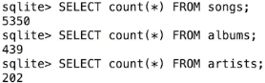

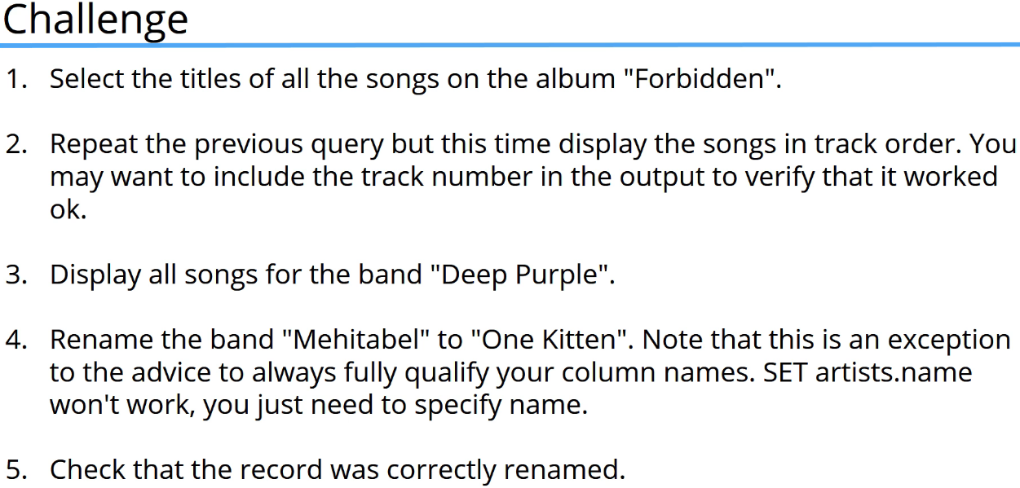

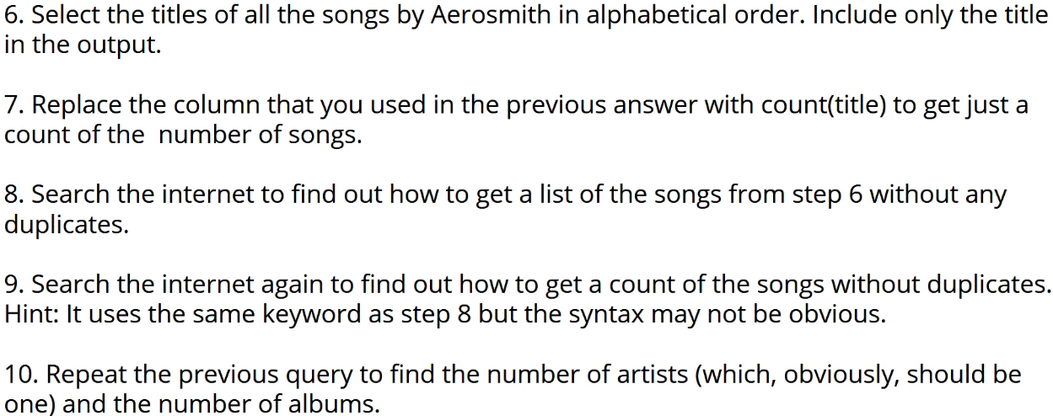  
* 1)  
  
* 2)  
  
* 3)  
  
* 4)  
  
* 5)  
  
* 6)  
  
* 7)  
  
* 8)  
**DISTINCT**  
* 9)  
  
* 10)  
  


**JDBC and SQLite GUI Browser**  
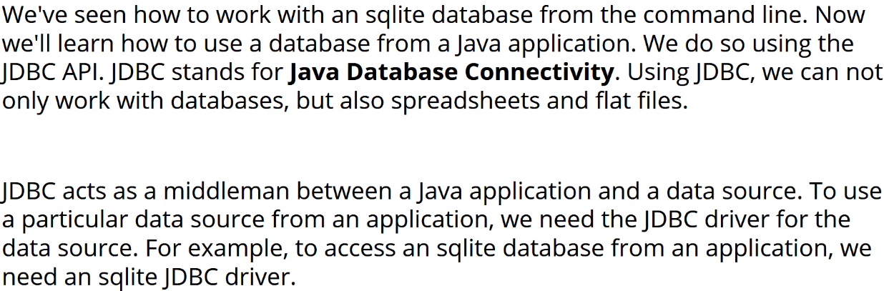

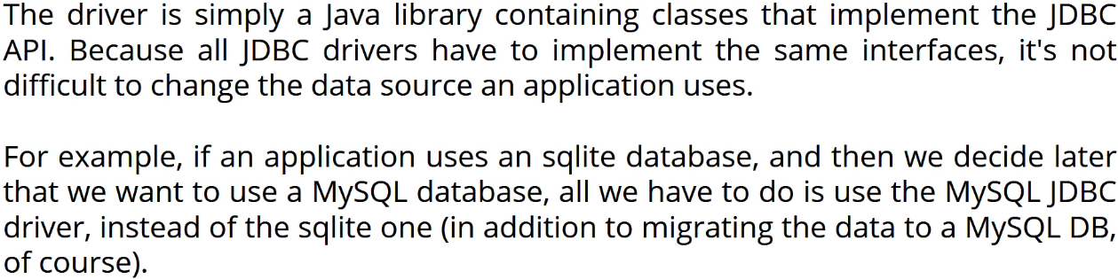

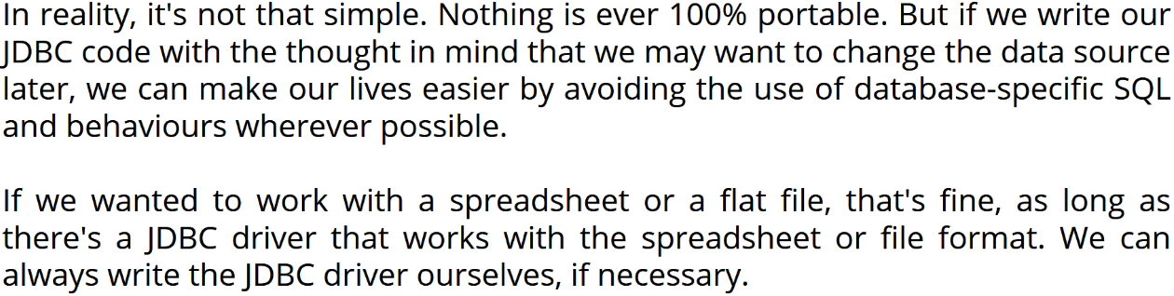

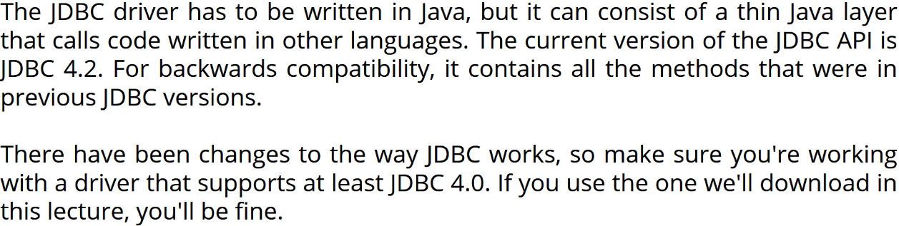

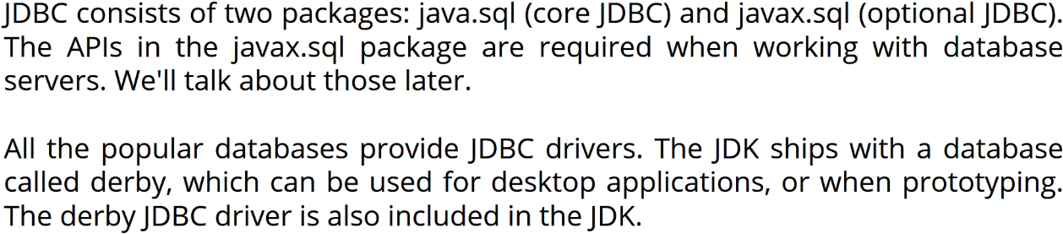

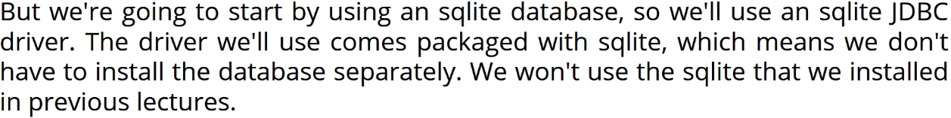

* There are other SQLite JDBC drivers but we’re using this one because it contains the SQLite database and doesn’t require any configuration.  
* Because we’ll add the `jar` file to any projects, there won’t be any conflict with the SQLite we installed to use from the command line.   
* So our application will use the version that’s in the `jar` file.  
* We’ll be wanting to check the contents of our database tables when we’re coding our application to make sure everything is working as we expect.   
=> I guess we could use the command line version of SQLite to connect to the database that we’re using in our application.  
**=> But instead we’re going to use the DB Browser for SQLite application which is basically an application that’s got a GUI interface that we can access SQLite databases for**.  
* For the rest of this video we’re going to quickly go through the 3 operating systems: Windows, Mac and Linux and show you how to go about installing that for each platform.  
=> **Windows**:  
**sqlitebrowser.org => Download => 64 bit for Windows => Install it => Open DB Browser for SQLite**  
=> **Mac**:  
**sqlitebrowser.org => Download => Mac .dmg => Install it => Drag it to the Applications folder**  
=> **Linux**:  
We’re going to download, compile and build and install the SQLite DB Browser for Linux.  
**sqlitebrowser.org => Download => .tar .gz file => copy link location => open terminal => navigate to where you want to install it => wget pasteLinkLocation => let’s also rename the file name: mv v3.9.1.tar.gz sqlitebrowser.tar.gz => now let’s extract it: tar -xvf sqlitebrowser.tar.gz => cd sqlitebrowser-3.9.1 => qmake => make**\* To install qmake you need QT => sudo apt-get install qt4-qmake cmake libsqlite3-dev libqt4-dev libqt4-qt3support => y  
* Navigate to where it is installed and then: ./sqlitebrowser.  
* At this point you can add it to the dash to do whatever you want to do, if you want to add a shortcut to get it to start each time for example.

**Creating Databases With JDBC in Java**  
* One thing to note about the DB browser is that if you use it to make changes to the database, it’ll actually lock the database file and you’ll no longer be able to access the database from a Java application.  
* **If that happens, you can go to File => Close Database**.  
* For JDBC, we need to add the SQLite JDBC Driver to the project.  
=> File => Project Structure… => Libraries => + => Java => navigate to the SQLite JDBC jar file that we downloaded and added => open => ok.  
* In a real-world application, often a database will ship with the application or the database wil exist on a server somewhere.  
* But sometimes you might want the application to create the database the first time it runs or perhaps the first time the user does something.  
* **When using SQLite, connecting to a database that doesn’t exist will create the database**.  
* All JDBC Drivers need a connection string that they’ll use to connect to the database. The exact format of the connection string will vary from database to database. But one thing they all have in common is that it starts with **JDBC:**. For example jdbc:sqlite: + the location of the database.   
* Other databases may require additional information. For example they might require the user enter a password.  
* And we can also specify database attributes with the connection string. For example we may specify that we want a SQLite database to be stored in memory.  
* To find out what’s required in a connection string for a given database, you can check out the JDBC Driver’s documentation.  
**Connection**  
**DriverManager.getConnection()**  
* **jdbc:sqlite:pathToTheDatabase**  
* IntelliJ shows the parameter names, I find it a little bit frustrating. You can turn it off by going to:  
**=> Preferences => Editor => General => Appearance => Show parameter name hints**.  
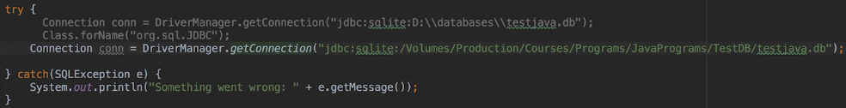  
* This is the new way of connecting to a database when you’re using JDBC 4.0 and above.  
* **When using earlier versions, we had to registere and load JDBC Drivers by calling the Class.forName() method with the driver class name**.  
  
* There’s actually 2 ways of establishing connection using JDBC 4.0.  
1) Using the DriverManager  
2) Using the DataSource objects => this is sometimes the preferred way and that’s because it allows advanced features like **Connection Pooling** and **Distributed Transactions** and it’s also more portable because of the way connections are established.  
* We don’t need these features when using SQLite and they require that the database administrators set up the database to enable use of these features. It’s also a lot more complicated to use DataSource objects and they’re really only needed when working with large enterprise applications, particularly JEE - Java Enterprise Edition applications.

* Whenever we want to use SQL with JDBC, we use **Statement Objects**.  
**Statement  
Connection createStatement()  
Statement execute()**  
* We don’t need to add the semicolon ; to the end of the statement and that’s because the Driver understands that when we call execute(), we’ve passed a complete SQL statement.  
* It’s also important to note that we created the Statement object by calling a Connection method so the Statement as such is associated with the connection and can only be run against the database we connected to when we created the Connection instance.  
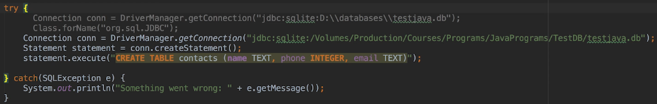  
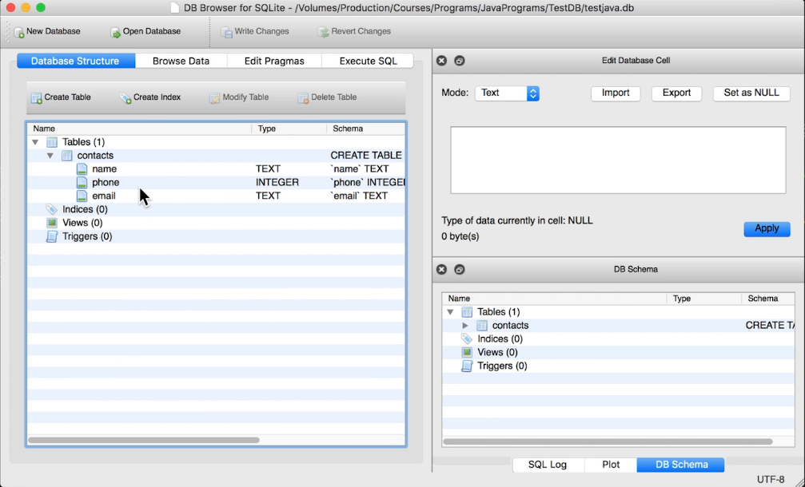  
* The connection on and statement objects use database resources so when we finish with them, we should close them. If we don’t, the Java Runtime will eventually close them for us but it is a good programming practice to close a resource as soon as we finish using it and we’re sure that we don’t need it again.  
* In trivial applications like this one it doesn’t matter but in large applications that use multiple database connections, if you’re not closing resources that you don’t need, it’s possible that you’ll run out of resources and the application would no longer be able to work with the database or perhaps the performance of the application will degrade.

* **You can of course use the TRY-with-resources to close it for us automatically**.  
=> The resources will be closed when the TRY CATCH block is exited.  
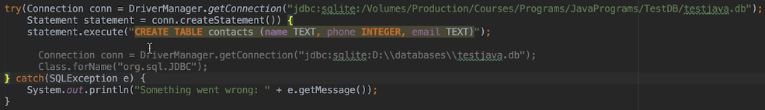  
=> **That’s the way I recommend**.  
* **But for now let’s stick with explicitly closing any resource we no longer need to drive home that it must be done this way. To get us into the habit of just closing this manually because it’s a good habit to get into as a rule**.  
Statement **close()**  
Connection **close()**  
* **The order in which we close database resource IS IMPORTANT, you should close() any Statement instances before you close the Connection**.  
* If you think about it, that’s logical because if we close the Connection first, then the database has been closed and actually what will happen is the SQLException will be thrown with a message SQL error or missing database and that’s because the Connection is closed.  
* So remember that a Statement is associated with a Connection so it’s sort of hanging on using that Connection so if you’re closing the Connection, we can’t actually use any Statements that were associated with it.  
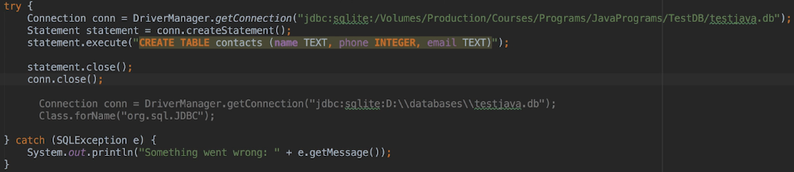

**JDBC Insert, Update, Delete**  
* If we run our code again, we get:  
* We only want to create the database the first time the application runs.  
=> We can tell SQLite to only create the table if it doesn’t already exist by adding the IF NOT EXISTS.  
**IF NOT EXISTS**  
* You can write it on multiple lines to make it easier to read.  
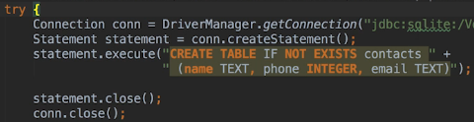  
* **We can reuse the Statement objects**.  
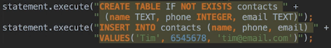  
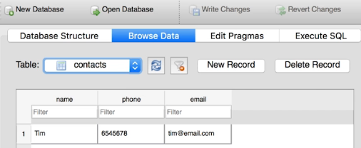  
* **The JDBC Connection class commits any changes we make to the database for us immediatelly after a statement is executed**.  
* Depending on which database you’re working with and what type of connection you use, sometimes you have to explicitly commit any changes you make to the database for those changes to persist and if you don’t commit them, then closing the connection also means losing any changes we made. They roll back.  
* The default behavior of JDBC Connection objects is to auto-commit all changes.  
**Connection** **setAutoCommit()**  
* If we set it to false and add something to our database, we don’t get any errors but we don’t see the new records.  
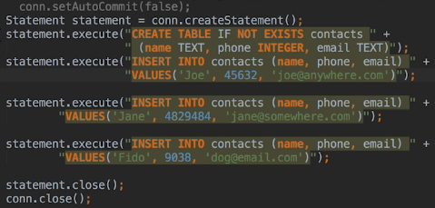  
* Let’s now use update.  
  
* Importantly again, it’s vital that we use a WHERE clause when we want to UPDATE or DELETE, otherwise all the rows in our table will be updated/deleted.  
  
* The Statement execute() method returns a boolean that will be true if the statement we executed returned an instance of the ResultSet class and false if it returned an update count or no results.  
=> For example when we execute() an UPDATE, the execute() method will return false because the result of the update statement is the number of records that were updated.  
=> When we query the database, the method returns the records that match the query as a ResultSet instance.  
* We can get the results by calling the Statement getResultSet() method. And we can then loop through the results.  
**ResultSet**  
**Statement** **getResultSet()  
ResultSet next()  
ResultSet getString()  
ResultSet getInt()  
ResultSet close()**

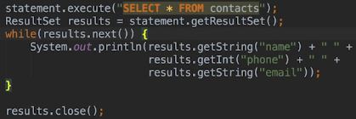 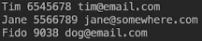  
* Every ResultSet has a **Cursor**. This isn’t the same as a database cursor. We could have had several ResultSet objects and each one will have a Cursor, however, if we reuse a Statement object to do a query, then any ResultSet associated with that Statement object is closed and a new one is created for the new query.  
* So if we want to work with several query results at the same time then it’s imperative to use a different statement instance for each query. Reusing the statement instance was ok when we were just doing INSERT, UPDATE and DELETE because we weren’t using or checking the result.  
* We can reuse a Statement object to query but only if we finish processing the results of one query before we execute() the next query.  
* **Keep in mind that a statement object ultimately can only ever have one active ResultSet associated with it**.  
* When a ResultSet is created, its Cursor is positioned before the first record and so the first time we call next(), the cursor will be moved to the first record. When there’s no more records, the next() method will return false.  
* And when we call one of the get methods, the values returned are those from the record at that ResultSet’s Cursor’s current position.  
* ResultSet is a resource so we have to close it. Because it’s associated with the statement instance, we have to close it before we close the statement.  
* Now we’re closing all our resources at the end of the TRY block. If an exception is thrown, it is possible that the close() methods won’t be executed even though some or all the other resources have been created.  
* For our small application it doesn’t matter. When the database objects are destroyed, they’ll do the appropriate clean up, the close() method forces the closing of the database resource immediatelly rather than waiting for them to be automatically closed.  
* Because of that, we don’t have to close them ourselves but it’s actually good practice to do so. Then if our code belonged to a large application in which there were lots of open connections, ResultSets and statements, we’d have ot be a lot more diligent about making sure the resources were closed as soon as we no longer needed them.

**.executeQuery() and using Constants**  
* There’s an easier way to perform queries and to get the results.  
**Statement** **executeQuery()** => returns a ResultSet  
  
* **We can also retrieve the values from a record using the column indices rather than the names**.  
* **Using the colum indeces is FASTER and so it’s the preferred way to do it. We’ll use them later**.  
* Using card-coded strings can make changes difficult because you’d have to updated all the places where they’re used.  
* Also it makes our application vulnerable to a **SQL Injection Attack**.  
* We can also write and use methods.  
* We could create a separate class for the string constants we define so that any class in the application will be able to access them but just to keep things simple, we’re gonna define them within the Main class.  
* Let’s also print the stack trace so that we can see where the error occurred.  
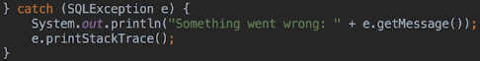  
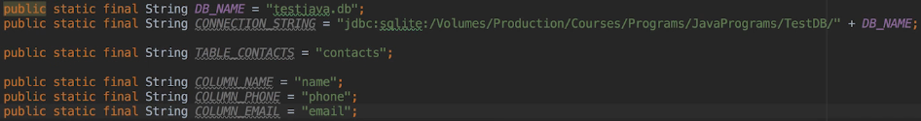  
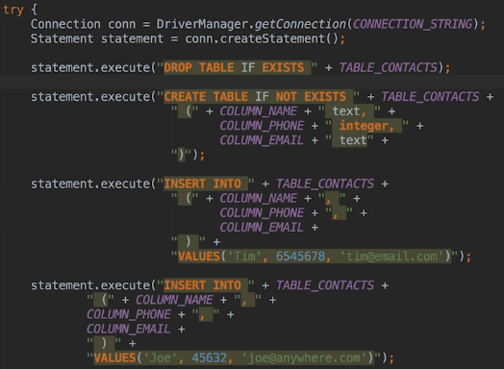  
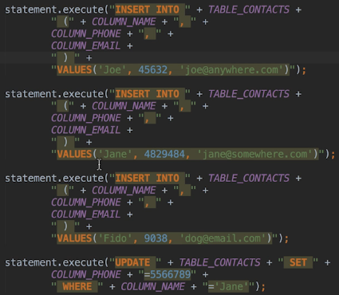  
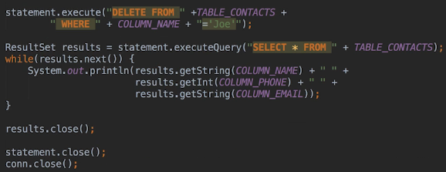  
* We replace the rest of the code in a similar way.

* Let’s now look at the **duplication of code**.  
* The 4 INSERTs are duplicated.  
=> **First let’s see the obvious way to do it but it won’t be the best way**.  
**(We’re gonna revisit running the same SQL statement but with different values in a later video)**  
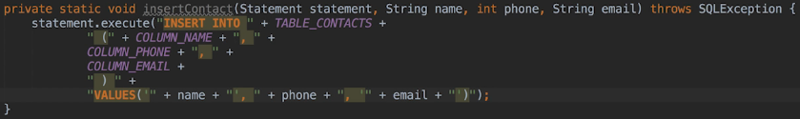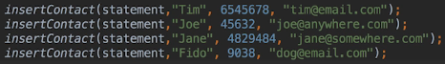

**The Music SQLite Database**  
* I added the music database we were using earlier:  
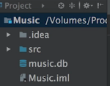  
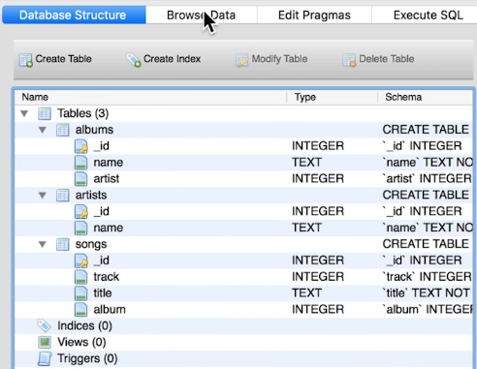  
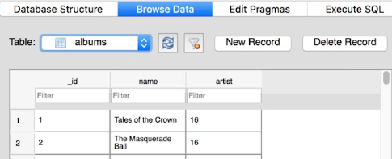  
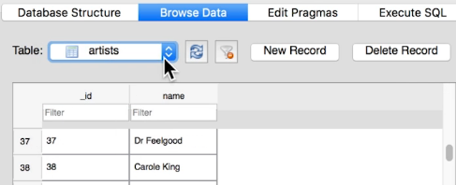  
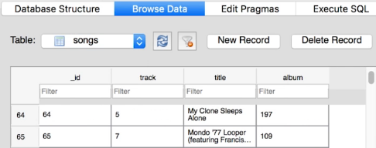  
* Now we’re going to start paying more attention to how we structure our code, especially since we’ll eventually want to work with the music database from a GUI-type application.  
* **Let’s create a new package called model**:  
=> New => Package  
=> Right-click it => New Class  
* Because all the tables have a column called _id and 2 of the tables have a column called `name`, you might be tempted to have only one string constant for `name` and one for _id, but it’s better to have one string constant per table. That way we can change the name of any column in a table without worrying about impacting on other tables.  
* **Let’s keep all our database code within the model package**.  
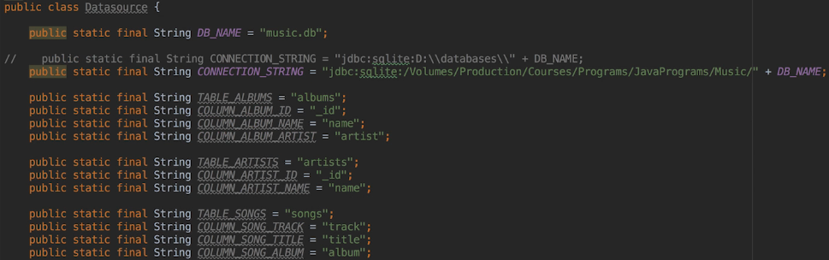

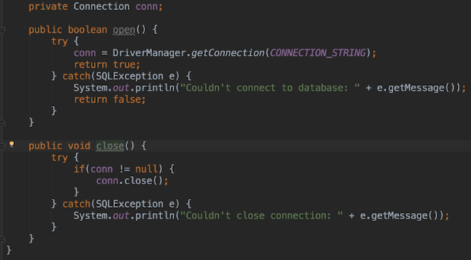

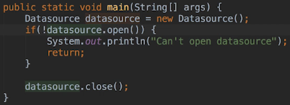  
* If we run it, we get:  
=> We haven’t added the SQLite JDBC Driver and database classes to the project.  
**=> File => Project Structure… => Libraries => + => Java => find the JDBC driver.**  
* **If you accidentally type your database file wrong, what happens is if it’s still a valid folder, the database will get created for you but it will be an empty database and you might be wondering at that point why you aren’t able to see that various tables**.  
* We’re going to add a method to the Datasource class to perform a query.  
* In large enterprise applications, we might create a class in the `model` package for each table and the connections might be coming from a Connection Pool. But for a small database like this, we’re going to keep our database methods within the Datasource class.  
* In this scenario do we want the method to return ResultSet? Actually NO, we don’t. Because we don’t want classes that use methods in the `model` package to have to understand the implementation details of the `model`. That way if we changed databases later, or change to something that isn’t a datbase - an XML file for example, we only have to change the code in the `model` package.  
=> So instead of returning a ResultSet, we can return a list of artists. And that means that we’re going to need classes for the artist, the album and the song.

**Write Java Query for Artists**  
* Last time we mentioned that we don’t want to return a ResultSet and that’s because we don’t want classes that use methods in the model package, to have to understand the implementation details of the model. So we need an alternative way to return the information.  
* We’re going to return a list of artists.   
=> To do that, we’re going to need classes for artists, album and song.

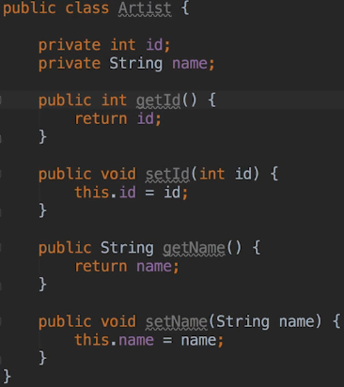 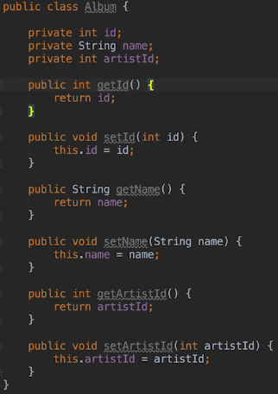 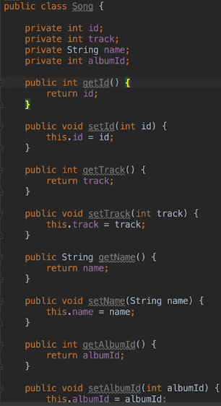  
* Now we can go back to our Datasource.  
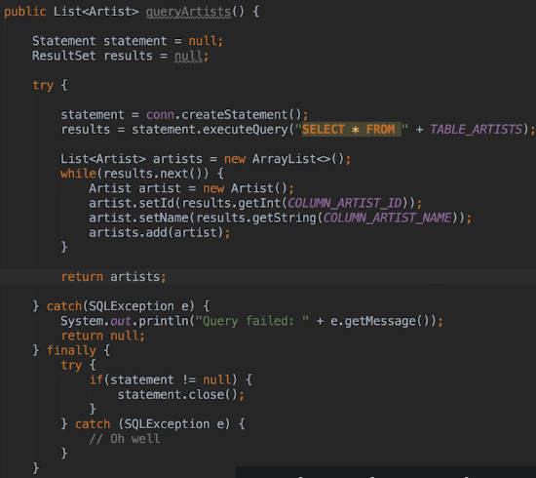  
* Let’s also close the ResultSet:  
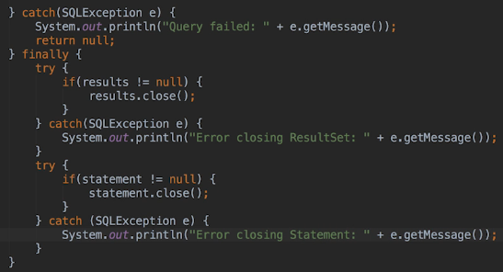  
* The reason for 2 TRY CATCH statement is because either one of the close() methods could throw an exception and when that happens, the second one wouldn’t be executed.  
* You probably notice that it’s getting a little bit messy here. Having multiple TRY CATCHes in the FINAL clause and then another CATCH above that.  
=> We could use the new form of TRY and declare the objects as part of the TRY statement or if you’re not concerned about closing database resources immediatelly after we finish with them, we could move the close() method calls into the TRY block and not worry about the case when an exception is thrown and resources are still open - because the Runtime would close them eventually.  
* But generally speaking it’s better that you cope that intention in your mind and to do this yourself with a TRY-with-resources or by putting it yourself as we did here.  
=> **Let’s use the TRY-with-resources**:  
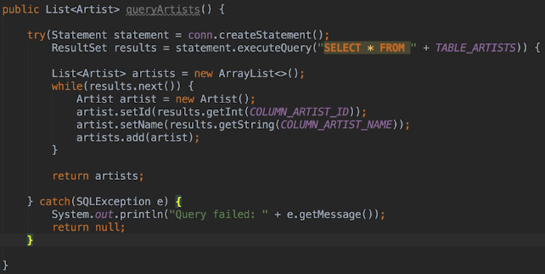  
* This way both the Statement and ResultSet will be closed automatically for us.  
* And obviously in this scenario callers of the method still have to handle a NULL return value however they see fit. In other words the process that’s calling the queryArtists() method has to check to see whethet what we’re getting back is NULL or not.  
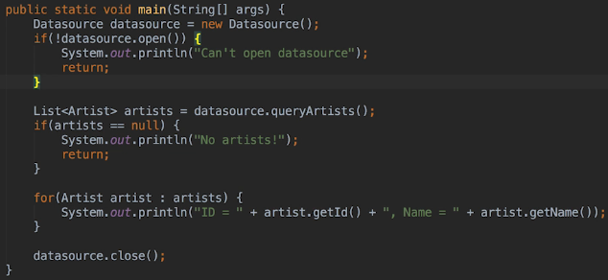  
* **Note that the main method code doesn’t make any assumptions about how or where the data is stored. So the data could be coming from an XML fine, a spreadsheet, a mySQL database or even a flat file**.  
* **If we change how and where the data is stored, as long as we don’t have to change any of the method signatures in the Datasource class, then we won’t have to change any classes that use it**.  
* **Our main method would remain unchanged in that scenario**.  
* A couple more things to note:  
1) => The Statement close() method closes the Statement and any ResultSet objects associated with it. So we don’t have to explicitly close() the ResultSet and that won’t make a difference to the code we’ve written but if we were explicitly closing resources, closing the Statement would in fact close the ResultSet.  
2) => We can make a quick improvement to the existing code. Right now we’re using column names to get the field values, but we can use the column index instead and that’s usually more efficient.  
* But with that said, there is a trade-off - if we use column names, we won’t have to change any code if the positions of the columns change within the table. For example we might add a column to the artists table and position it between the existing _id and name columns.  
=> If we’ve used name columns, we won’t have to change any code.  
=> But if we’ve used our column indices in our, then we would have to change them. However, this is easily handled if we use constants for our column indices which, of course, we will do.  
* **It’s important to note that when working with ResultSets, the index we pass to the ResultSet getter method is the index of the column in the ResultSet, not in the table**.  
* When we retrieve all the columns, the ResultSet indices will be the same as the table indices but otherwise the ResultSet indices may not actually match the table column indices.

**Executing SQL in DB Browser**  
* **Column indices are 1-based => 1st column is at position 1**.  
* The reason for that is if you use a 0, you actually get an Exception.  
* Let’s add column indices constants.  
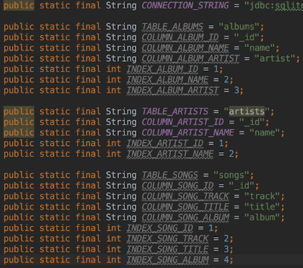  
* Let’s change the method to use it:  
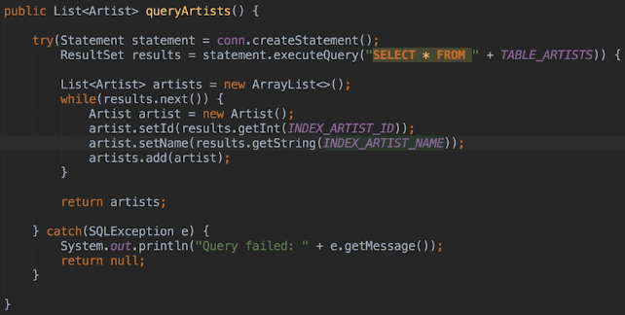  
* The getInt() and getString() are basically overloaded methods that also take an int instead of a String.  
* It’s more efficient to use the column index because the getter methods will know exactly where to go to get the value in the ResultSet.  
* When we used the column name, the method has to match the column name against the columns in the ResultSet.  
* Let’s now create more speicific queries.  
* Keep in mind that when working with the real-world application we don’t usually have to accommodate every possible query that can be made against every table.  
=> What we usually do is look at the UI for the application whether that be Web Pages or Mobile Screen or a Desktop Window and we figure out what queries we have to perform to populate each web page, window screen etc. with data.  
* And those are the queries we want to accommodate in our Datasource class.

* Let’s assume our application allows users to do the following:  
> view a list of artists  
> view albums by particular artist  
> view songs on a particular album  
> find out which artist recorded particular album  
> find out which album a song is on  
> find out which artist recorded a particular song along with the album the song is on and the track number  
* We’re not going to code them all here but we’ll do a number of them.  
* We’ve already coded the method that retrieves a list of artists.  
* Unfortunately there isn’t an elegant way to build query strings when using JDBC. It would be nice to be able to create a query string by chaining methods together - something like select.join.orderBy etc., and there might be Third-party libraries that give us the ability to do just that but the base API doesn’t unfortunately.  
* Of course we could write methods that behave this way ourselves but that is getting a little bit outside of the scope of what we’re trying to do in this section.  
* So to perform the query we want, we have to build up a query string and then pass it to the Statement executeQuery() or execute().  
* But first let’s modify the queryArtists method to accept a parameter that indicates if and how we want the artists to be sorted.  
* We’ll need string constants in the Datasource class that callers can use to specify the sort order.  
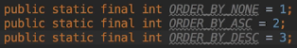  
* **We could’ve used an ENUM instead. In some instances it might actually make more sense because we’d be validating the enum as a parameter so we can only specify that. Whereas at the moment, the way we’ve defined that queryArtists and the int that has been passed to it, it’s just an integer so it’s possible to pass an invalid value here that wouldn’t be used**.  
* ASC is the default behavior, for example if there’s an invalid number.  
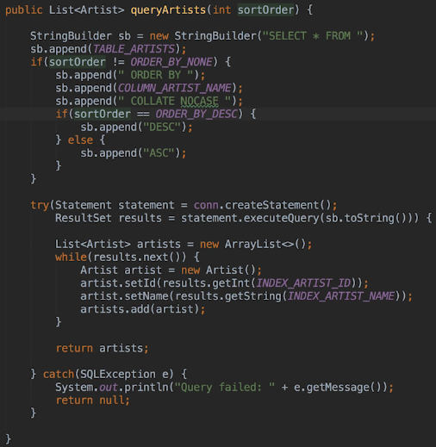

* In main let’s pass the order number:  
  
* Let’s now write the method that will retrieve all the albums by a particular artist.  
* But first let’s try out the SQL statement in the DB Browser.  
=> It’s always good practice to test the SQL we want to use before coding it.  
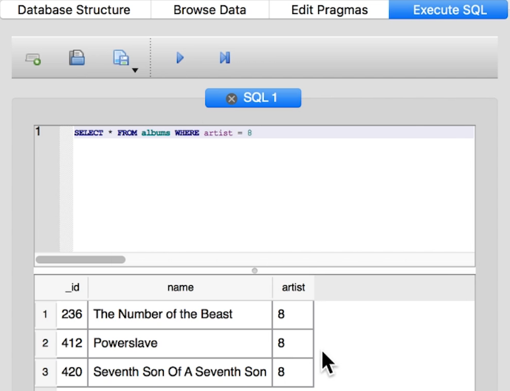

**Query Albums by Artist Method**  
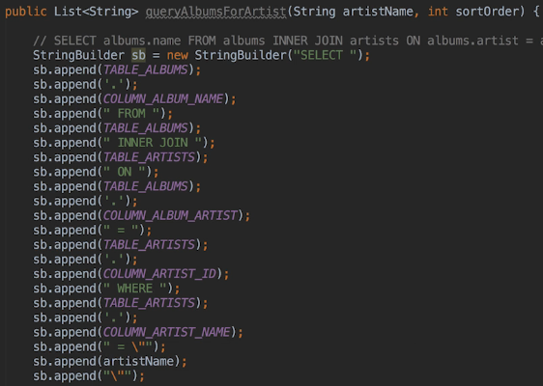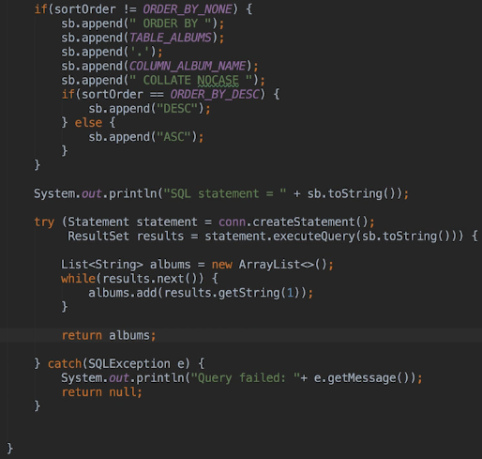  
* A good rule of thumb here is to print out the value (especially in the early days) to make sure it’s correct.  
* Our query only returns the album names so there’s only 1 column so we can hard-code 1.  
* In Main:  
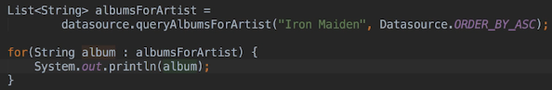  
  
* **Looking at that statement, most of the statement is static. It’s really only the artist’s name and sort order that may be different each time the method runs**.  
=> **So rather than building the query statement from scratch each time the method executes, we can define bits of it as constants**.  
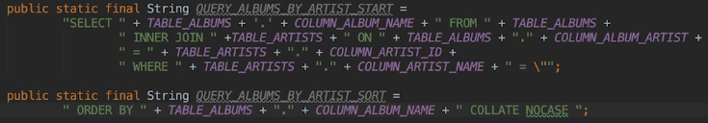  
* We could’ve used StringBuilder with a bunch of chained append() calls but since the concatenations will only take place once when the Datasource instance is created, we’re going to stick with concatenations.  
* **Often a data source class like Datasource is used as a singleton and that would mean there would only ever be one instance of the class**.  
* I’m sure you agree that these strings look pretty ugly so if we ever have to change the name of a table or column, we’ll be glad we didn’t hard-code any names. We really only have to type these strings in once.

* **Hopefully now you can start imagining how you might end up with lots of constants which is why they’ll often be put into their own classes**.  
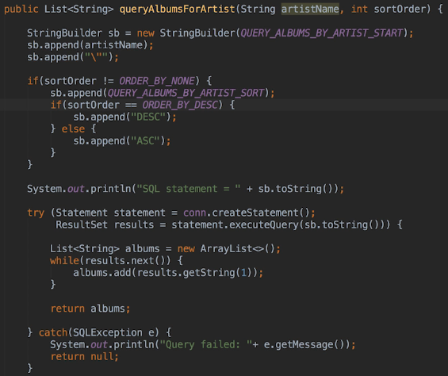  
* The method is now a lot more concise and I think better and easier to read.

**Query Artists for Song method**  
* It would be nice if we could somehow have a placeholder in the SQL statement for the artist’s name so that we could dynamically replace it every time we perform a query rather than having to append the artist name to the statement. We’ll do that in future video in this section.  
* Now let’s add a method that returns which artist recorded a particular song.  
* We want to return the artist name, the album name and the track number for the song of the album.  
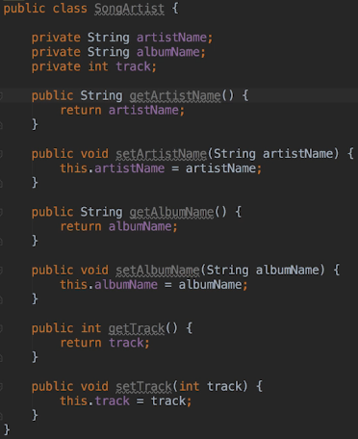  
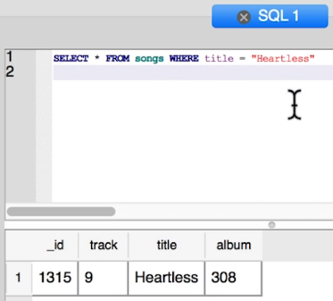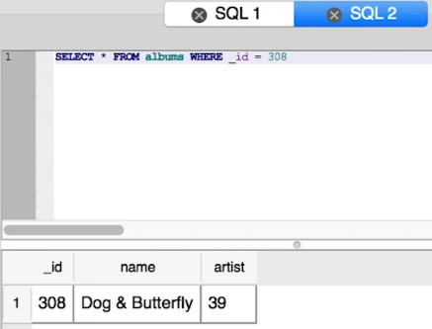  
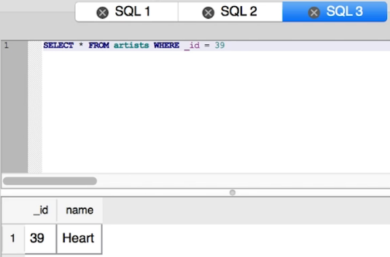  
* So we know that our SQL is right and we’re able to get the information we need to achieve what we want to do.  
=> **We need to create an INNER JOIN on those various tables to get the information**.  
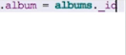  
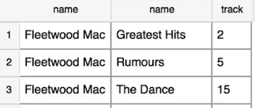  
* The only varying parts are the song title and sort order.  
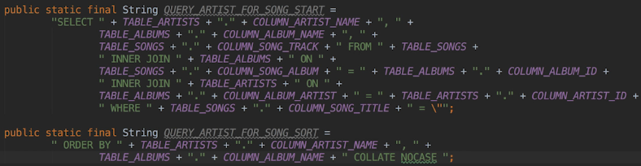

**Result Set Meta Data**  
* We can’t use our column index constants because they’re returning columns from different tables.  
* We’re okay to hard-code indices because we can be sure that the order of the columns returned for this query will always be the same even if the column position has changed within the tables.  
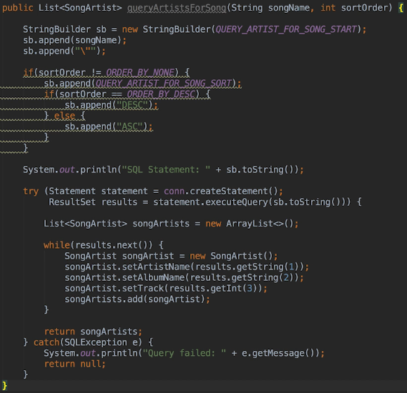  
* Now in main:  
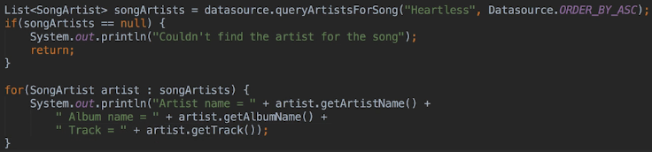  
  
* Alright so those are all the queries we’re going to code for now. Doing the others would just be a matter of defining the static constants and then building up the string in a new method. Depending on the query, we may have to create a new class to hold the results.  
* Hang on to these classes because starting with the next video we’re going to be using them again but also when we use the music database from the GUI application later in this section.  
=> **Because we’ve been diligent about hiding the implementation details from the callers of the Datasource class, we’re going to be able to just drop the classes in a model package into our GUI application’s project and use them as is**.  
* **If we had mixed database code with the code in the main method, we wouldn’t have been able to do that. At least not as easy**.

* Let’s touch on one more topic.  
* When we were working from the command line we were able to query the schema from the tables in the database. But when using JDBC, this is one area where the support for this and sometimes the way we do it, can be different depending on the database.  
* **Unfortunately, SQLite doesn’t have good support for querying the database schema**.  
* The Connection class has a **getMetaData()** method that is supposed to return information about the database tables but when using this method with a SQLite database, unfortunately the returned object doesn’t have any of its fields set, they’re all NULL.  
* What we can do though is query meta data using the ResultSet from a query. Often this is sufficient because we’re usually interested in the defition of a specific table.  
* For example we may want to get the column index for a value or find out what the column names are for a table.  
* In Datasource file:  
**ResultSet** **getMetaData()  
ResultSetMetaData** **getColumnCount()**  
**ResultSetMetaData** **getColumnName()**  
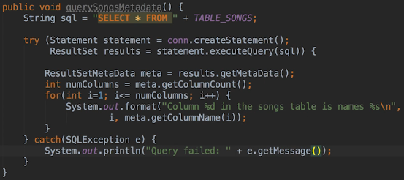  
* **Using the ResultSetMetaData we can get information such as the column names and types and their attributes. In other words whether they’re NULLABLE etc**.  
* In main:  
  
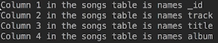  
* Relation to the other types of information that we can look at, let’s go to Oracle’s documentation.  
* There’s quite a few methods that do various things so it’s worthwhile checking that out.  
* **If you’re in a situation where you don’t know the names of the columns in the table or how many there were, we can do a query that doesn’t require that information and then get it from the ResultSet. Of course we need to at least know the name of the table**.  
* This is one area (getting schema info) where the support and the way of getting it can differ across databases.

**Functions and Views**  
* How do we access the result of functions in a query? Such as:  
SELECT COUNT(*) FROM songs  
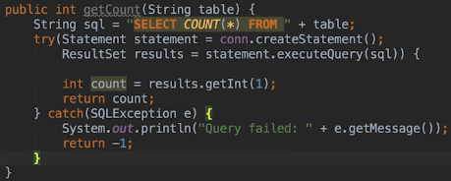  
=> **We treat the function result as a column**.  
  
  
* In case you’re wondering, the fact that our constant name has TABLE in it doesn’t break the separation between our model code and the rest of the application. Nothing about it forces me to know that the data is stored in a database.  
* If we change it to:  
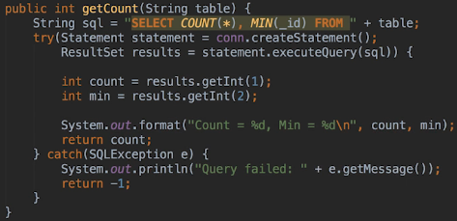  
=> **This works but it is good practice to assign names as the resulting columns using AS**.  
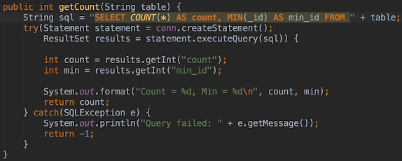  
* **Doing it this way means that if we alter the query to retrieve more results and the column positions of the resulting values change, we won’t have to change the getter calls**.  
* Now let’s briefly take a look at creating and querying Views. I say briefly because there’s really nothing special about working with Views using JDBC. We do exactly what we did from the command line.  
* **When we need to use Views from an application, it’s possible that the views will ship with the database. In addition, we don’t want to create the View every time the application runs**.  
* Let’s create a view so that when the user wants to know the artist for a song, we can query the view instead of a join.  
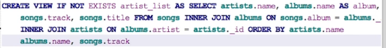  
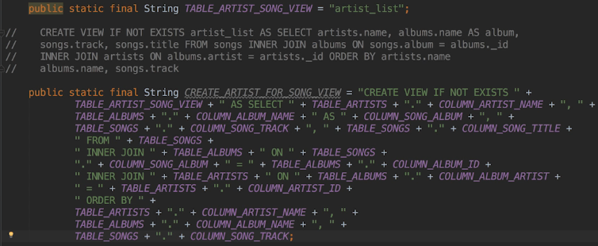  
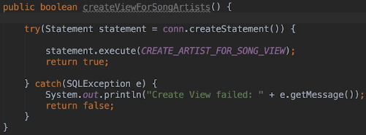  
* In main:  
  
* We can confirm that it’s there:  
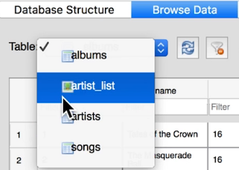

**Write the Method to Query View**  
* Now that we’ve created that view, we could actually change the queryArtistsForSong() method to use the view. But we won’t do that now.  
* What we’ll do instead is create a new method for this.  
* The user of the Datasource class could fall back to using the queryArtistsforSong() method if the creation of the view fails or if calling the new method results in an error.  
* We can query a view just as we query a table.  


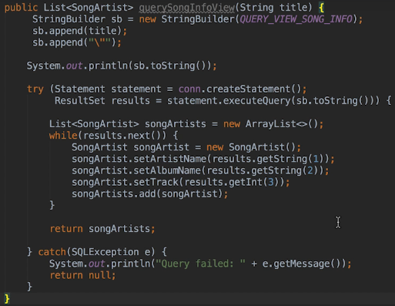  
* I’m going to turn off the IntelliJ feature that warns you about duplicated code for now.  
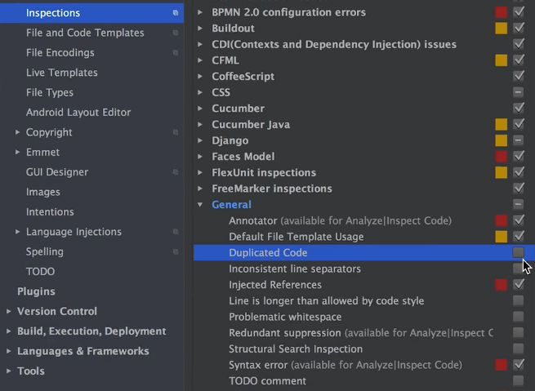  
* **But you should refactor the code that loops through the result into another method**.  
* We can reuse the songArtists list in our main:  
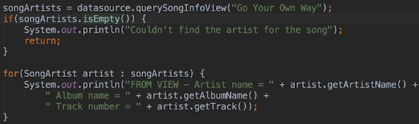  
* **We should’ve been using the isEmpty() for all our queries in main.java rather than checking for NULL since we always at least create the list in the Datasource methods**. When no records were returned, we wouldn’t see the message printed to the console. Using isEmpty() is a much better way of checking for that.

* Our code is decent at the moment but there’s one more important improvement we can make. In fact the way we query the database now isn’t best practice.  
=> **SQL statements have to be compiled into a form that the database understands. When we use a statement object to perform queries, the statement is actually compiled every time we perform a new query**.  
=> In an enterprise application, servicing thousands of connections, that would definitely impact performance.  
=> **And also the way that we’re building query strings makes a database vulnerable to hacking attempts**.

**SQL Injection Attacks and Prepared Statements**  
* **Let’s demonstrate how the way that we’re building query strings makes a database vulnerable to hacking attempts**.  
* We’ll let the user enter a song title in the console and then we’re gonna call the query method.  
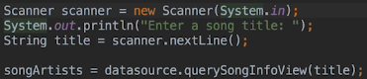  
  
=> This returns every row in the artist_list view.  
* The actual SQL:  
  
**SQL Injection Attack => The user has injected SQL into the statement that we didn’t intend to run.**  
* The thing was when we built the SQL statement, we’re blindly concatenating whatever the user’s typed. Since 1=1 will be true for every record, all the records in the artist_list view are returned.  
* The hackers guess that we could be concatenating the name into a where clause and since it’s a string, they guess that when concatenating a closing quote.   
* A malicious user can even do something like DROP tables. Since we’re using JDBC, we do have some protection against that, at least when using the SQL JDBC Driver, the execute() and executeQuery() methods won’t run more than a single SQL statement so in other words a user can’t tack on something like ; DROP TABLE songs. But if an application written in the language like perhaps PHP was running SQL directly based on user input rather than going through an API, than the malicious user would be able to execute whatever SQL statements they wanted.  
=> So instead of building up query strings and using the statement class to execute them, you should really be using the PREPARED Statement class.  
**PreparedStatement** => can protect against SQL Injection Attacks because when we use them, we don’t concatenate user input into the SQL statement that will ultimately be running.  
* Now the only thing that changes between queries is the song title.  
=> It would be nice if we could have placeholders in SQL statements for the values that change from query to query and PreparedStatements allow us to do just that.  
**? => Placeholder character that we use in PreparedStatements.**  
  
* **We don’t put the quotation marks around the song title anymore. When replacing a placeholder in a PreparedStatement, the database understands that a string is one value. So we only substitute a single value for each placeholder**.  
* **We also need to declare an instance variable for the PreparedStatement because we only want to create it once. We want it to be pre-compiled once**.  
* Otherwise we would lose the performance benefit that a PreparedStatement has.  
**Connection** **prepareStatement()**  
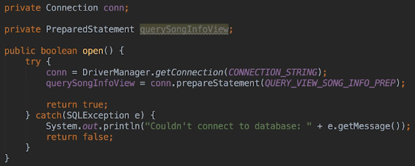  
**PreparedStatement** **setString() => specify the position (1-based) we want to replace and with what.**  
* Change:  
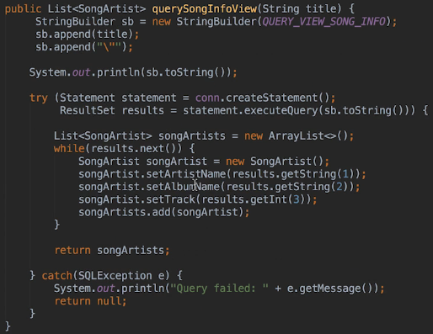  
* To:  
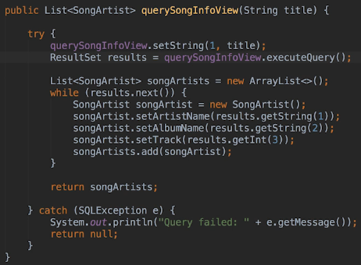  
* PreparedStatement is a subclass of Statement, in other words it’s got all the other methods that Statement has, such as execute(), executeQuery(). **We keep executeQuery() empty**.

* We’re no longer declaring the resources as part of the TRY statement because I changed it so consequently what we need to do now is put a FINALLY clause in there to close them.  
* I mentioned that if we close a Statement, any associated ResultSets are also closed and I also mentioned that there can only be 1 active ResultSet associated with a Statement.

=> **If we use a statement to do more than 1 query, which is very common with PreparedStatements, each time we need to do a new query, the existing ResultSet is closed and a new one has created**.

=> **So we don’t have to worry about closing the ResultSet when using the PreparedStatement. When we close the PreparedStatement, whichever ResultSet is active, will also be closed**.

* **And we should also close the PreparedStatement in the close() method as opposed to closing it in this particular method**.  
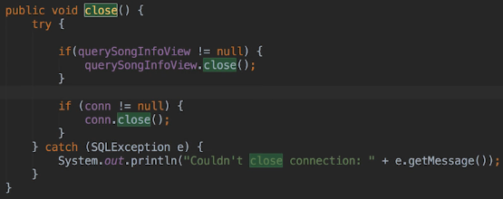  
* **Here the order is important, we can’t close the Connection first because we need an open connection to close statements. Basically we always close resource in the reverse order to which they’re opened**.  
* We don’t have to change the main method because it doesn’t know/care about what type of statement we’re using to get the data.  
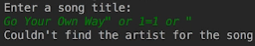  
=> When we’re using a PreparedStatement, the values being substituted are treated as literal values. In other words nothing within the value is treated as SQL. When we were using a StringBuilder to build the query statement and concatenate the title, effectively this is what was passed to the database and not executed:  
  
But in the 2nd scenario with PreparedStatement, we get different result:  
  
What the user typed in has basically been substituted for the song title. So it’s really just the double quote that’s making all the difference. And so the database is being searched for song that equals   
`Go Your Own Way or 1=1 or “` in its entirety.  
* **So a malicious user can’t inject SQL into the statement because anything substituted for a placeholder is treated as a single literal value and won’t be interpreted as SQL**.

**Transactions**  
* Let’s say we wanted to use OR within a PreparedStatement, something like:  
  
* Think of it this way - for each value we need a placeholder. We can’t substitute more than 1 value for 1 placeholder and we can’t inject SQL. Also we can only substitute values, so we can’t use placeholders for things like table and column names. That’s because in order to pre-compile the statements, the database needs to know which table we’re querying and which columns we want.  
* So the only information we can postpone until we want to perform the query are the values themselves.  
* Also we can use PreparedStatements with INSERT, UPDATE and DELETE the same way as SELECT.  
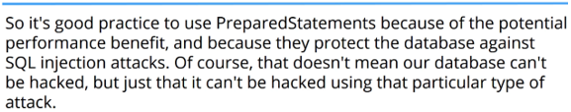

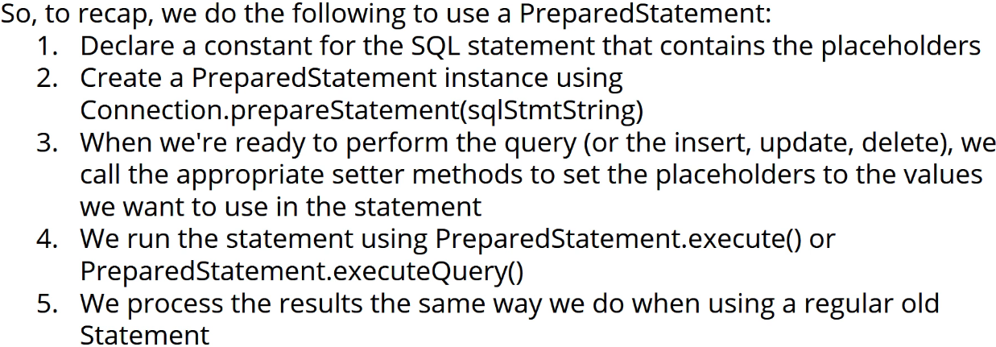

**Transactions**  
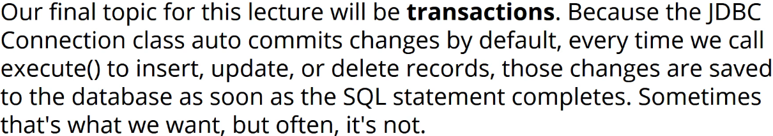

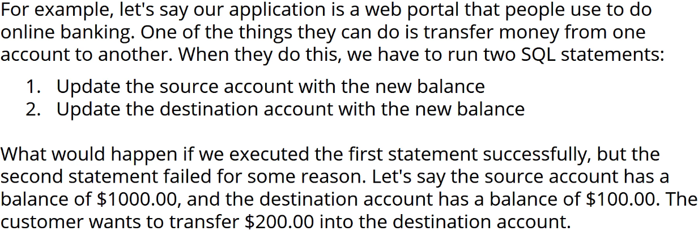

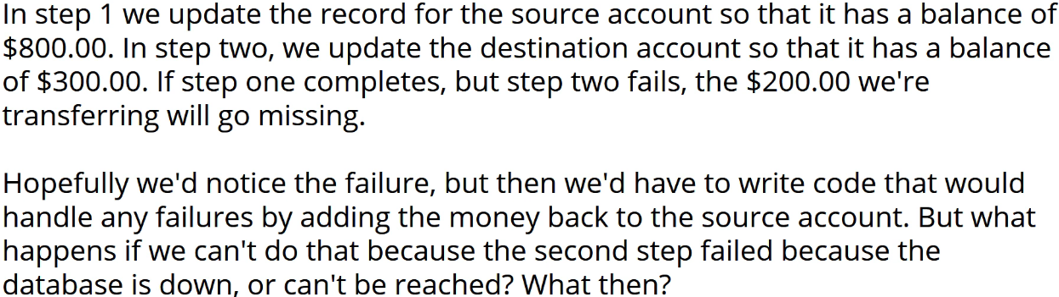

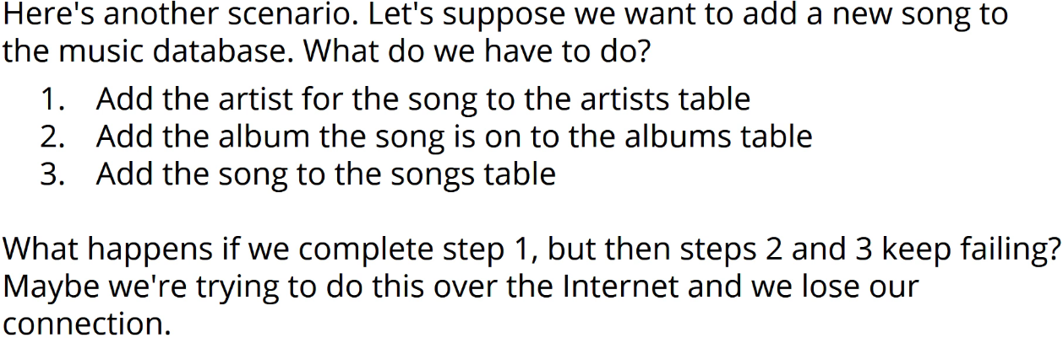

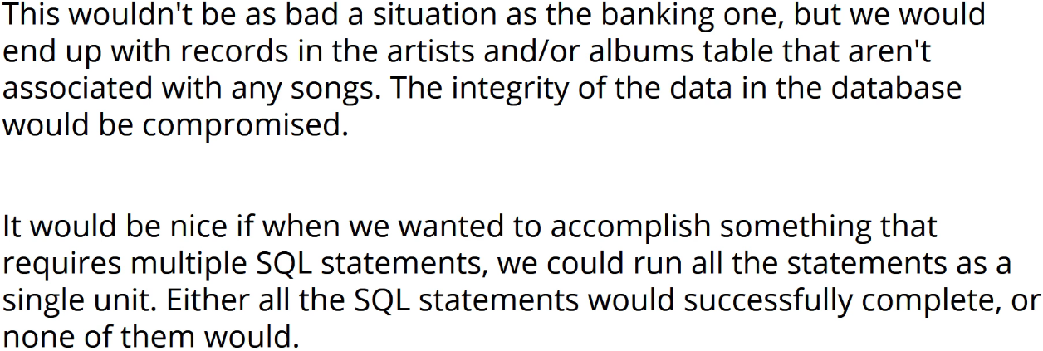

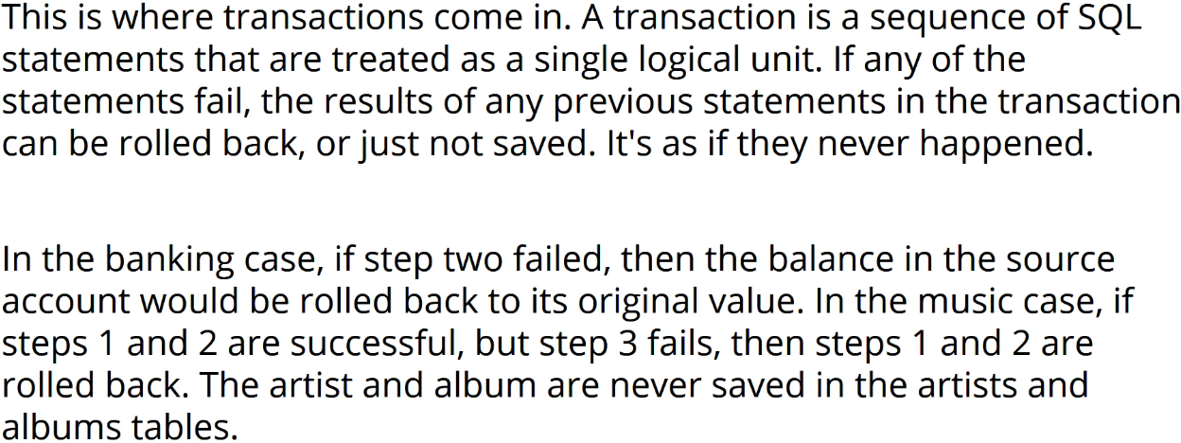

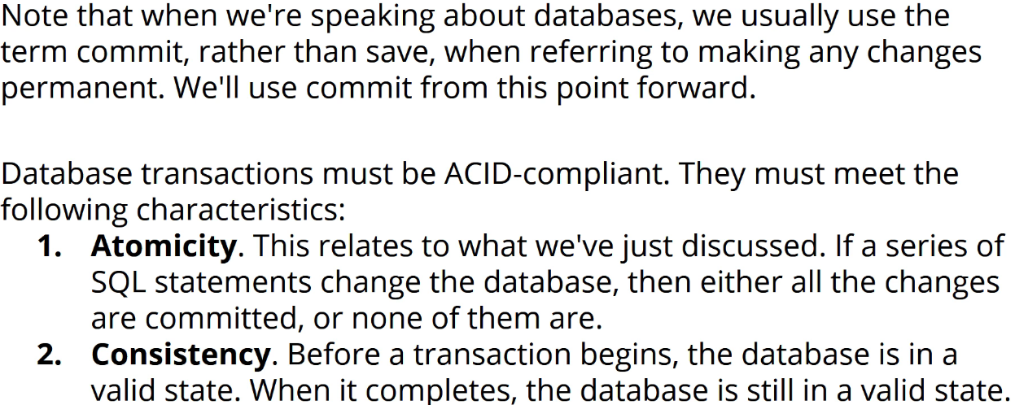

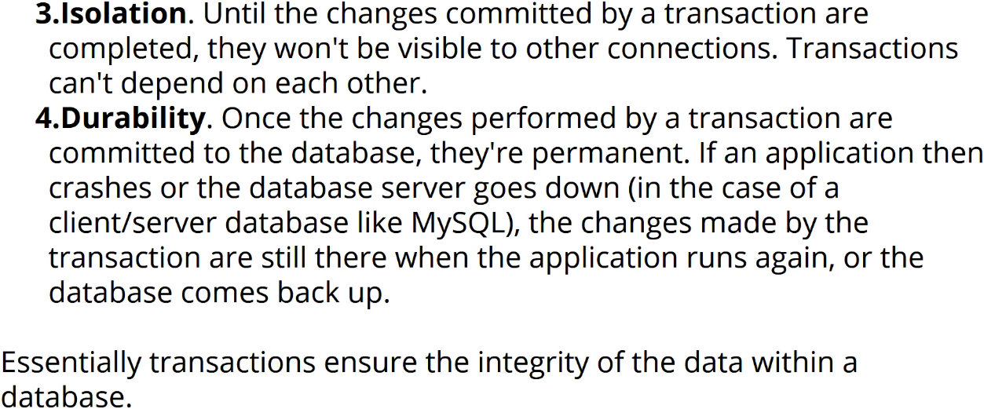

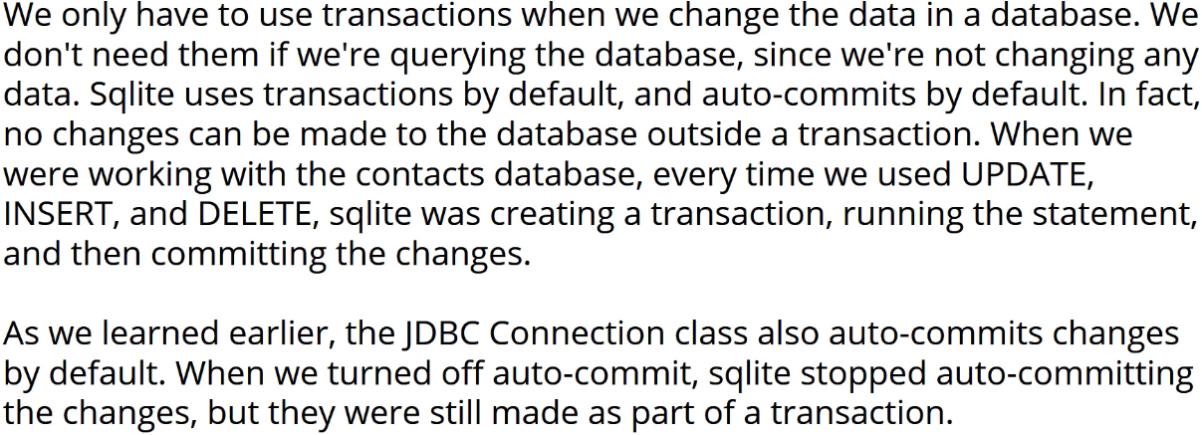

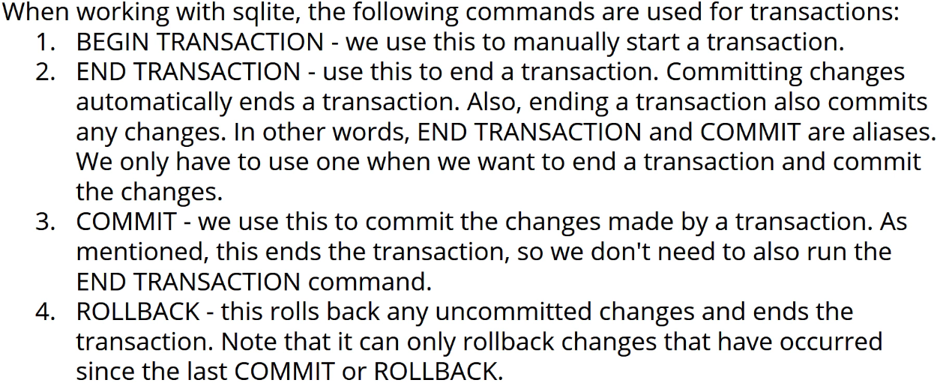

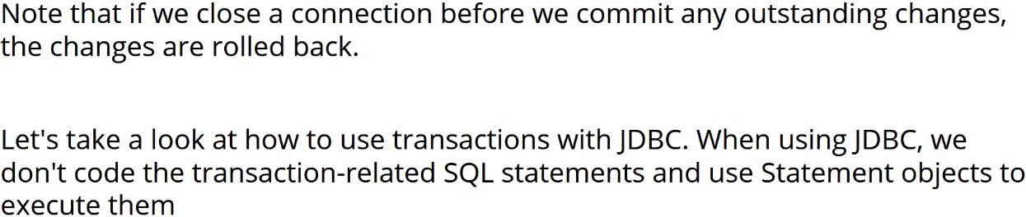

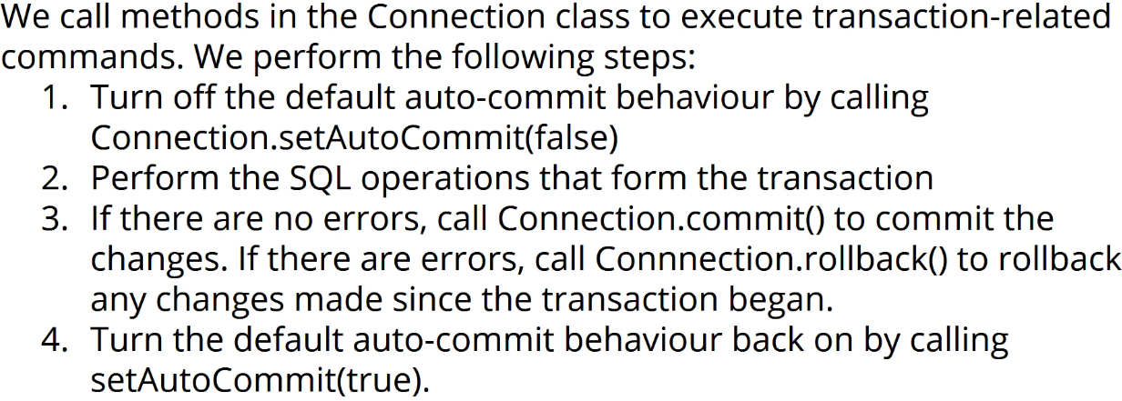

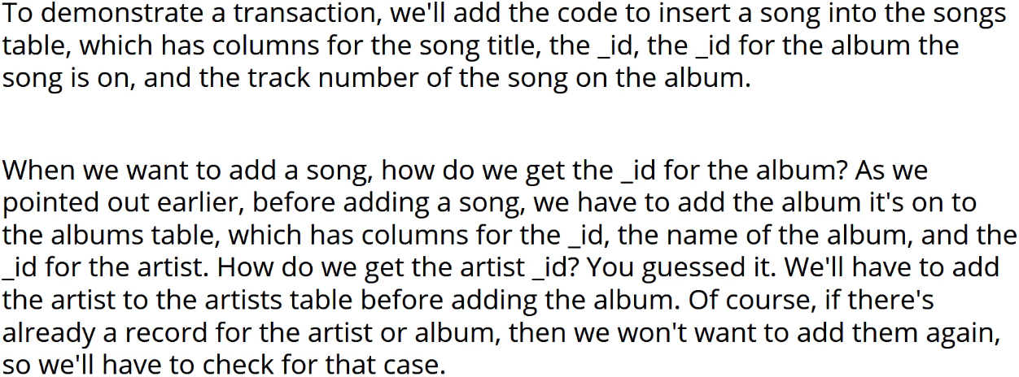

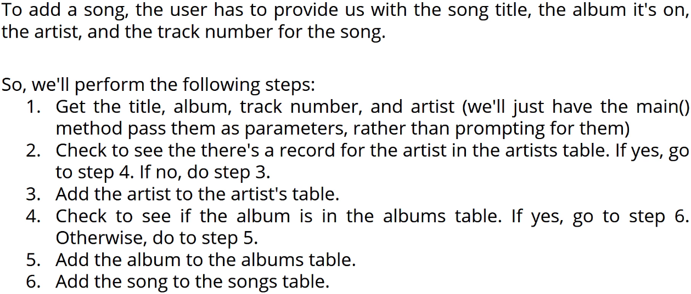

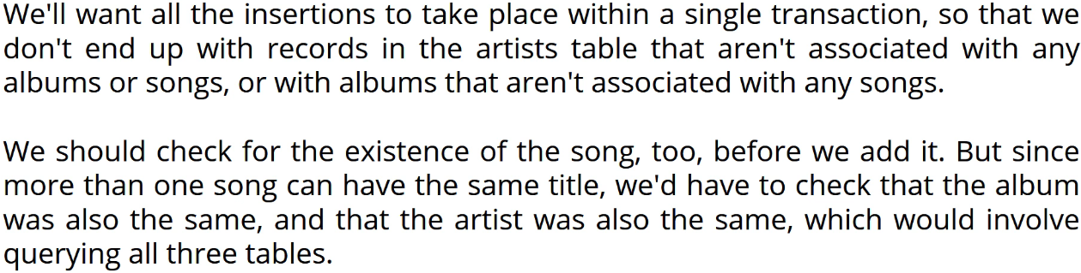

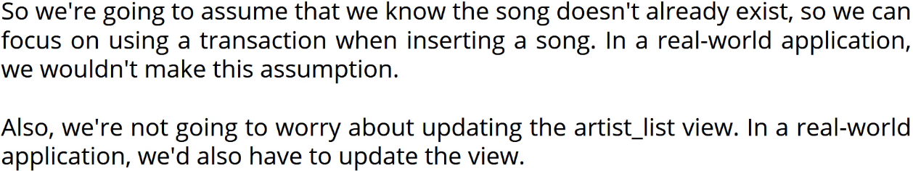

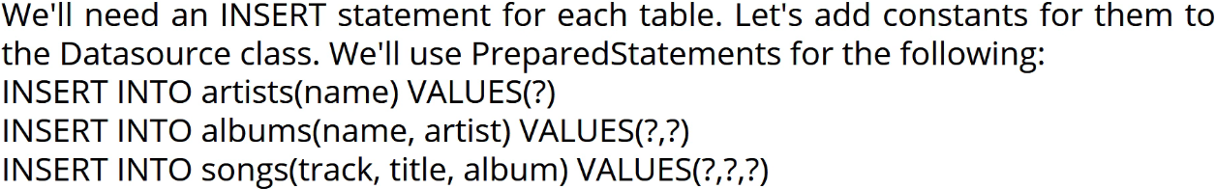

**Inserting Records With JDBC**  
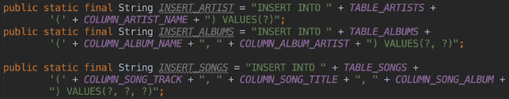  
* We’re going to add the code to the open() method to create the PreparedStatement instances.  
* When we insert an artist or album, we need to know what _id the database assigned to the record.  
* The _id is the key and the database generates the value whenever it inserts a record into the table.  
* So we need to use the artist ID when we insert the album and the album ID when we insert the song.  
* When we want to get the generated key after statement is completed, we have to add another parameter to the PreparedStatement calls.  
* **Statement.RETURN_GENERATED_KEYS** => we’ll then be able to get the key from the PreparedStatement object.  
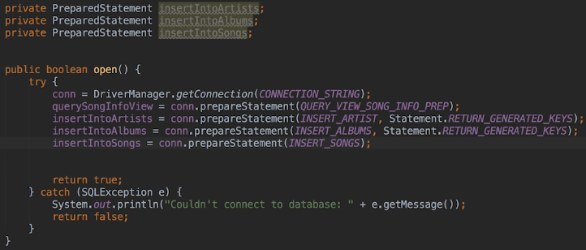  
* Let’s also close them in the close() method.  
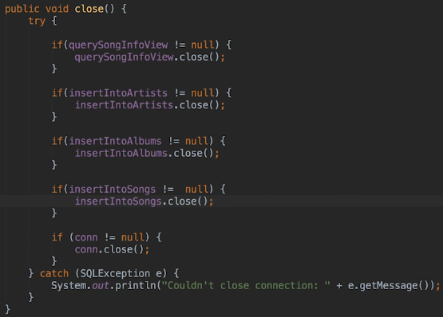

* Now we’re going to create 3 methods - one for each table.  
* The methods that insert an artist or an album, will first check to see if the artist or album already exists and if it does already exist, it’s going to return the _id column for the artist or album. But if it doesn’t exist, it will then add the artist, album and then return the ID from that insert.  
* **These methods (artist, album) will be private because they should only even really be called by the method that inserts a song, which will be responsible for creating the Transaction and committing the changes**.  
* To achieve that, first we need to add the constants for the statements that we’re going to use to check whether an artist or an album already exist.  
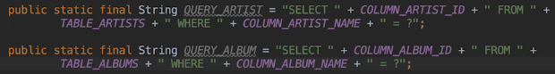  
=> The SELECT is going to return the ID but the WHERE clause is doing a search by name. So we get back the ID that we can then use for the insertion if that already exists. If it doesn’t exist, then we’re going to return the new ID after the insert. So that way whether the record is on file or not, we’re going to get the right ID.  
* And then also in the case of both of these, we only need the ID returned from the SELECT so that’s why we’re only returning the relevant ID column.  
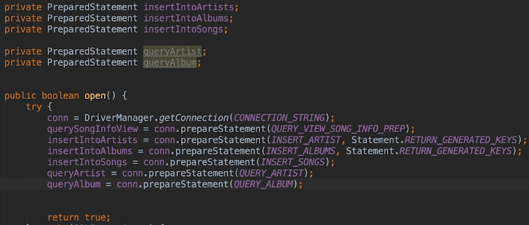  
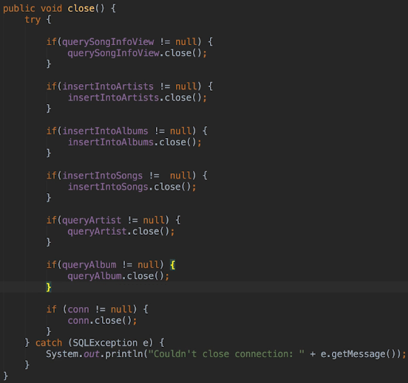  
**Insert Albums, Artists, and Songs**\* If we get a number back from our first query, we know that in this case the artist is already on file, so we’re returning the ID of the existing artist and then exiting method.  
**PreparedStatement** **executeUpdate()** => that should not only save the record but it will actually tell us how many rows were updated, in this case that should only be one.  
**PreparedStatement** **getGeneratedKeys()**  
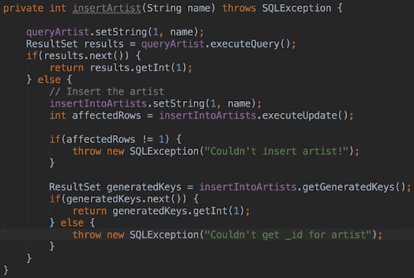  
=> First we’re querying the artist table to see if the artist already exists. If it does, we return the ID.  
=> We’re using exectureUpdate() instead of the execute() method because the execute() method returns a boolean indicating what type of result the executed SQL statement returned. The executeUpdate() returns the number of rows affected by the SQL code that ran.  
=> Then we get the generated key so we get the key value, the artist _id in this case.  
=> I’m throwing SQLExceptions in the method because we want the caller to handle these. And we’ll see how this makes things cleaner soon.  
* The query album is pretty much the same except we have to change some variable names and messages and we have to set 2 values in the PreparedStatement.  
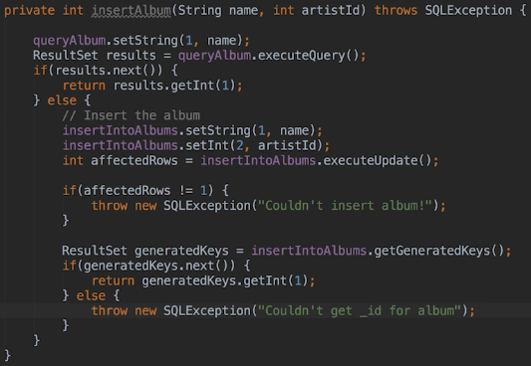

* Now let’s create the insertSong() method.  
**Connection setAutoCommit()** => **because we’re going to perform our own Transaction**. **Connection rollback()**  
* We need to get the ID for the artist and the album based on the artist name and album name that have been passed to this method.  
=> insertArtist() => will return the new or existing ID, it’s the method we created.  
=> insertAlbum() => will return the new or existing ID, it’s the method we created.  
**Connection commit()**  
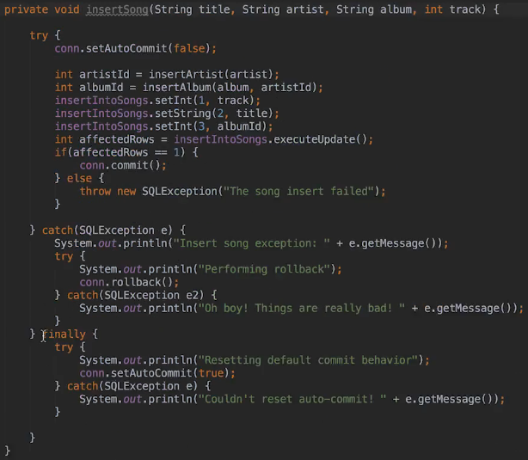

**Test Insert JDBC Code**  
* **First we turned off the default auto commit behavior because the** **default behavior is to commit every change and the way the database does that is by running every UPDATE, DELETE, INSERT statement as a Transaction**.  
* When we want to run a series of SQL statements as a Transaction, we signal that by turning off the default behavior.  
* From that point forward, we’re actually in a new Transaction.  
* The rollback() backs out any changes we’ve made since starting the Transaction and it will also end the Transaction.  
* **Because using Transactions involves getting database locks, it’s best practice to only turn off auto commit for the duration of a Transaction and to turn it back on again immediatelly afterwards**.  
* Hopefully now at this point you can see why we have the insertArtist() and insertAlbum() methods both Throw SQLException rather than handling it. **What it means is that all the code that makes up the Transaction, is actually now in one block and quite easy to read**.  
* The insertSong method should be public so that we can access it in the main:  
  


  
* Songs:  
  
* Albums:  
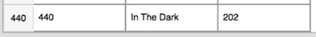  
* Artists:  
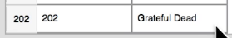  
* **We didn’t check for the existence of the sort in the insertSong() method so if we ran the code again, it would create the song again**. We’d need to create another constant and execute that additional query.  
* Let’s introduce an error:  
  
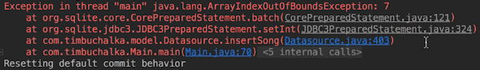  
* You see the invalid index is 7 which means that under the covers the indices are being mapped to a 0-based index which raises the question of why the JDBC API uses 1-based indices in the first place.  
=> **We can see a new Album was actually added and a new Artist was also added, but not the song**.  
=> **What happened is we got an ArrayIndexOutOfBoundsException, not an SQLException. That’s why we didn’t get a rollback here**.  
* The next question would be: didn’t we set auto commit to off?  
=> **Yes, we did it but as a consequence of going through this TRY CATCH and FINALLY, the FINALLY code block was executed, we set auto commit to true and that’s got a side-effect of doing a commit**.  
* How do we get around this?  
=> What we really want to do here instead of just a SQLException, we want to catch all exceptions.  
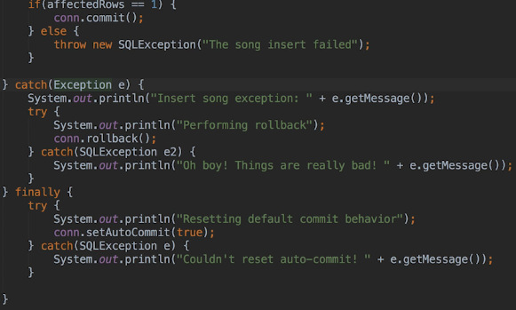  
* This we if any Exception is thrown, we get the rollback().  
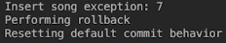

* At this point you now know how to work with Transactions using JDBC.  
=> **We use them when we want to perform a series of SQL statements as a unit so that the changes are only committed to the database if all the statements ran successfully. If a statement fails or something else happens - perhaps a lost connection or the database server goes down in the middle of performing a Transaction, then we won’t end up with a database in an invalid state. We’ll be ble to rollback() any changes that have been made or if the connection goes down for some reason, the database will automatically rollback any changes and end the Transaction**.  
* One final note here - **it’s also possible to rollback() a Transaction to a specific point rather than running back all the changes that have been made since the Transaction started**.  
=> To do this, we need to call the Connection **setSavePoint()** method which returns a SavePoint object. If we need to rollback() the changes that have been made since we created the SavePoint, we pass the SavePoint to the Connection rollback() method.

**JDBC with a GUI Program**  
* Let’s use JDBC from within a UI application.  
* JDBC calls themselves are the same but:  
When do we create the Datasource class?   
How do classes in the application access it?  
How do we perform database operations so that the user interface doesn’t freeze?  
How do we report the results back to the user?  
* Let’s answer these questions.  
* I’m going to assume at this point that you’ve watched the JavaFX section of the course and there from I’m only going to explain the UI specific concept if it’s new and hasn’t been previously covered.  
* The UI will be fairly simple: we’re going to be using a border pane with a table view in the sent position. We’re also going to have a progress bar which won’t be visible when the application starts and at the bottom of the window will be where that resides in an H box. In the right position we’ll place a V box containing several buttons. Pressing a button is going to perform a SQL operation. We’re going to have 3 buttons: list artists, show albums for a selected artist, update artist.  
* That may not sound like much but each one here’s going to demonstrate something different that can be extended to similar operations.  
* The list artists button will query all the data in a table and present that to the user.  
* The show albums artist button will need to do a query based on a selected record and then display the results.  
* The update artist button will demonstrate what’s involved when performing one of the CRUD operations that changes existing data in the table.  
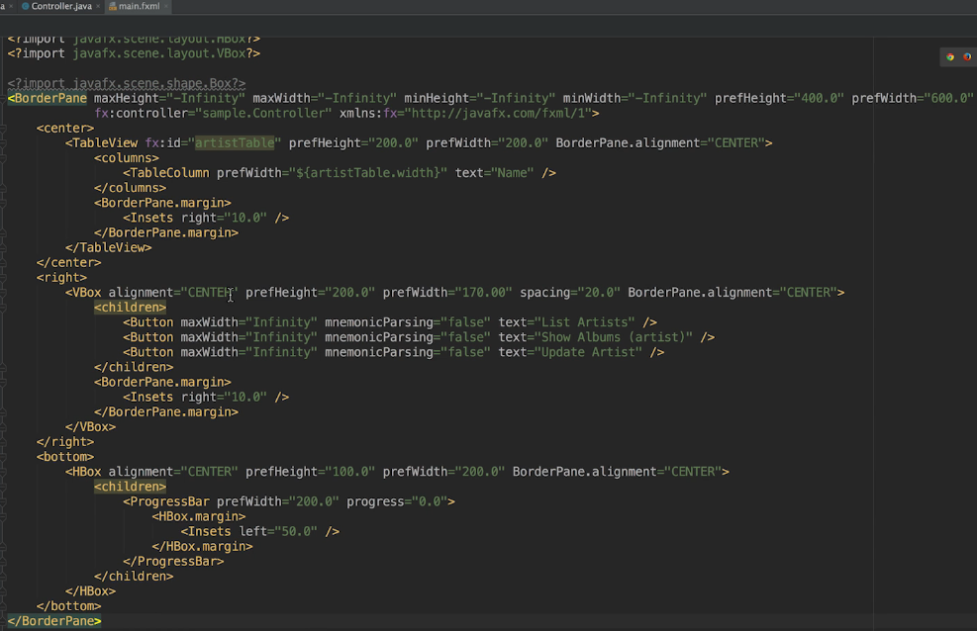  
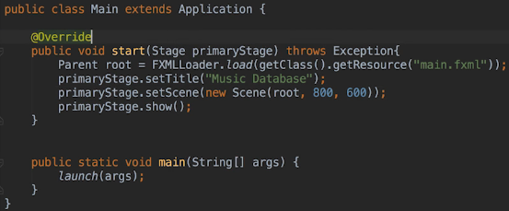  
* This is our basic interface, what we currently created:  
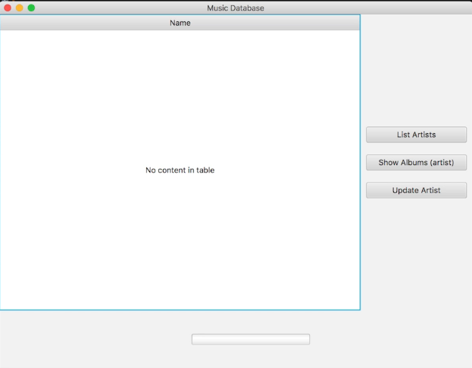

* Let’s now make the progress bar invisible:  
  
* In a real-world application you’d probably do it in such a way that there was an empty space near the bottom but again, we’re not focusing on the user interface right now.  
* Let’s get our model files:  
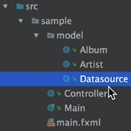  
* We want the Controller to be able to use the Datasource class. In a real-world application, we’d probably have more than 1 Controller and they’d all need access.  
* We could have each one create an instance of the class but which one then would be responsible for managing the connection by calling the open() and close() methods?  
=> **Well, when working with a Datasource, it’s quite common to use a Singleton pattern for the Datasource class. It’s called a Singleton pattern because we use it when we want an application to create only 1 instance of a particular class**.  
=> So every object that needs to call methods in the Singleton will use the same instance of the Datasource to do so.  
* **Turning our Datasource class into a Singleton is quite straight forward**:  
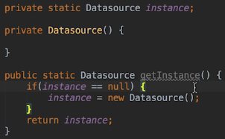  
=> We created a private constructor.  
=> We created a private static instance of the Datasource class.  
* We can create the Singleton instance when we declare the variable or we can create it in the static access method which is what we’re going to do in this case.  
**Lazy Instantiation** => **the instance isn’t created until the first time it’s needed**.  
* This is a perfectly valid code but it’s not keep in mind it’s **not Thread-safe**.  
=> **It’s possible for a Thread to be interrupted after the check for null here. Another thread could then run, check for null and create instance. Then the first thread can run and create the second instance. Then the application would have 2 instances**.  
=> **What we should really do here is create the instance when the instance variable is declared and that will actually be Thread-safe**.  
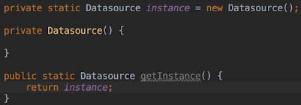  
* **This way is also Lazy Instantiation because the instance won’t be created until the first time the class is loaded, which will be the first time some other insteance references the class by calling the getInstance() method**.

* Where to call the open() and close() methods for Datasource?  
=> It would make sense to open a connection to the database when an application is started because our main window wants to show data from the database.  
=> It would also make sense to close the connection when the user shuts down the application by closing the main window.  
* So we’re going to make use of the JavaFX Lifecycle methods to open and close the database connection.  
* The Application class contains Lifecycle methods that are either Abstract or Concrete but don’t actually do anything.  
=> So we’re going to override the init() method to call the Datasource.open method and we’ll override the stop() method to call the Datasource.close method.  
* The init() method runs before the start() method that creates the UI.  
* The stop() method runs when the application is shutting down, either because the application has explicitly done something to close it or because the code called Platform.exit().  
* Both the init() and stop() methods are implemented in the Application class but by default they don’t do anything.  
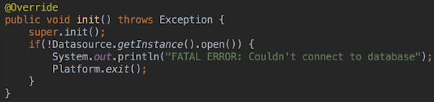  
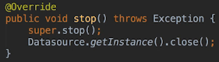  
* There’s no need to call the super() methods because they don’t do anything here.  
* **We also need to add the JDBC Driver to the class path**.  
* We want to let the user know that something’s wrong and then close the application. Normally we would do this using a pop-up dialogue but since this isn’t a UI set of videos, we’ll just write a message to the console.

**Add Artists**  
* When the application starts, we want to show all the artists. The user can ask to see all the artists later as well. So we need to show them when the application starts but also potentially in response to user input.  
* **Remember that we always want to perform long tasks on a background Thread, not on the main JavaFX Application Thread**.  
* When we want to run background threads from a JavaFX application, we need to use helper classes in the javafx.concurrent package.  
* Because we may need to use this task form 2 places (at start up and when the user explicitly asks to see all artists), we’re not going to use an anonymous task class that we create in response to user input. We’re going to add a getAllArtists task class to the Controller.  
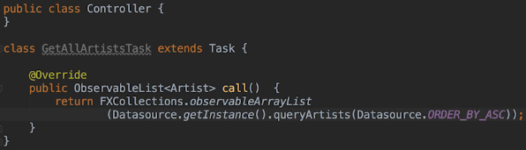  
* Again, the reason that we’re creating a separate class here and putting it in the Controller.java file is that we may need to use this task in 2 places.  
* If we want to use data binding to populate the table, the call() method, which we’ve reconfigured, has to return an ObservableList<Artist>.  
* **We don’t want to change the queryArtists method to return an ObservableList because that would violate the separation between the `model` and UI code**.   
* **We could use the `model` classes as is, if we didn’t want to take advantage of data binding**.  
=> Here we do want to take advantage of that, so consequently, we do need to make 1 small change to the Artist class to achieve that.  
=> Instead of storing the artist name in a string, we need to store it as a SimpleString property. This doesn’t violate the model UI separation because SimpleString property isn’t a UI specific class. We could’ve used it all along actually.  
* We’ll do the same for the artist _id even though we’re not displaying it.  
* Because the fields will now be properties, the getter and setter methods are all gonna change as well.  
**SimpleIntegerProperty  
SimpleStringProperty  
set()  
get()**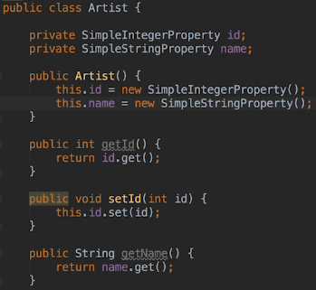  
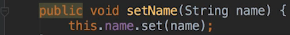  
* Again, we’re only doing this because we want to use data binding.  
* Since this is a simple application, if we wanted to keep our `model` classes exactly as they were, then we could do that and we would explicitly then set the table items when the task completes.  
* There are 2 ways we could set the items:  
1) Covered in the Threading section of the course   
2) We could call Platform.runLater() when the queryArtist() method returns its results. And in the Runnable we passed to run later, we could set the table items **artistTable.getItems().setAll(ArtistResults).** I also mentioned that we can do more with Tasks that we covered, including running code when the core method completes. To do that, we need to call **Task.setOnSucceeded and it wants an Event Handler**.  
* In our case the most straight forward way to pass the code we want to execute is to use a Lambda.  
* So we’re going to do something like this:  
  
=> Whenever Data Binding makes sense, it’s best to use it because then we don’t have to do anything when the Task completes, it’s all handled automatically.  
* We have to make 1 more step for Data Binding to work, though.  
=> We have to map the name field in the Artist class to the name column in the table.  
=> We accomplish this by adding a cellValueFactory to the table column.  
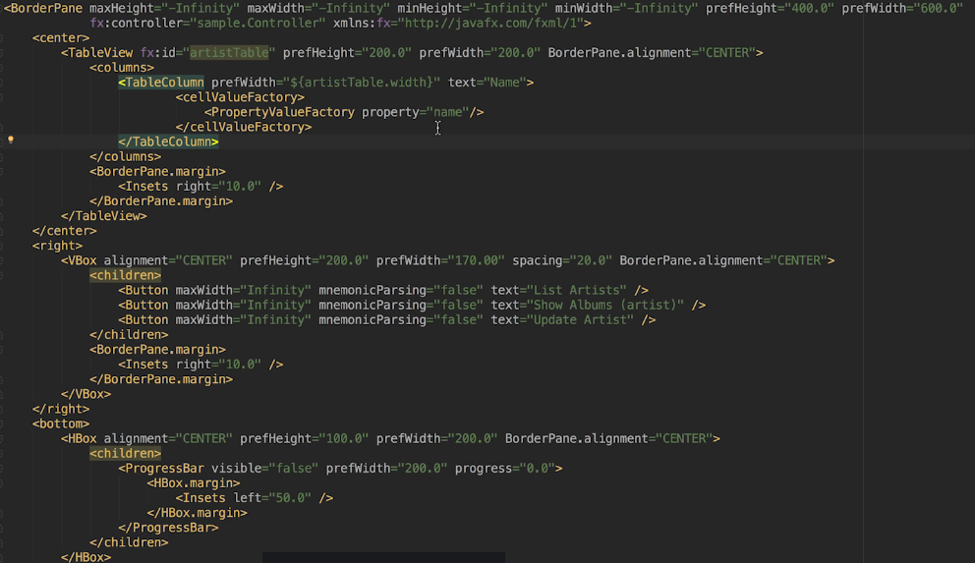  
* The property=”name” maps to the name field in the Artist class.  
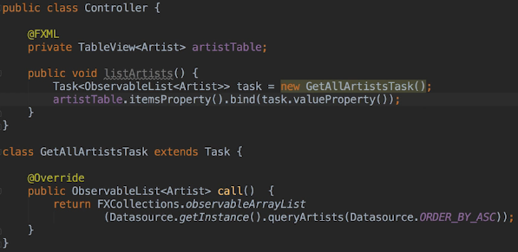  
* We’ve created a new Task object, then we’re binding the result of the Task (in this case the artists ObservableList) to the table view’s itemsPropert(). So they’re actually bound to each other.  
* Next, we’re going to start looking at how this is going to be invoked because the Controller isn’t created until the FXML is loaded.

**Fix Artist and Preload Records**  
* Because the Controller isn’t created until the FXML is loaded and that happens in the start() method and also because we want to be sure that the UI has been built before we try to load these results --- because of all that, we’re goint to initiate the query of the artists from the start() method.  
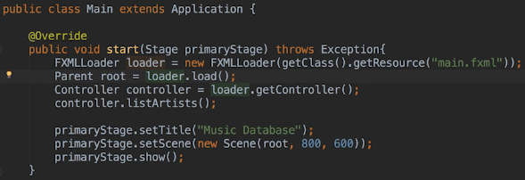  
* There’s one problem - we’ve set up and changed our start() method to invoke the list of artists and in the last video we set up the cellValueFactory with property=”name” and also from our Artist.java we should be returning a name.  
=> **The problem is we’re not actually kicking off that task in listArtists() - the GetAllArtistsTask**.  
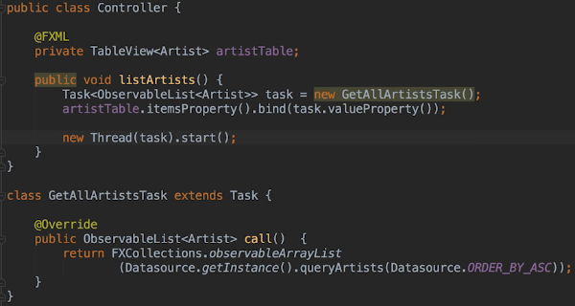  
* Now if we run it, sometimes you will find that it has tried to load some records in but for some reason, they’re blank:  
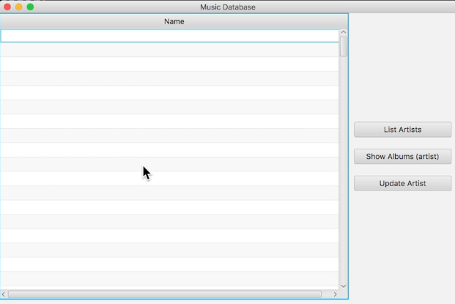  
=> It’s a bug seemingly with IntelliJ  
* If I paste this code again - the same code, it then works:  
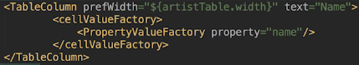

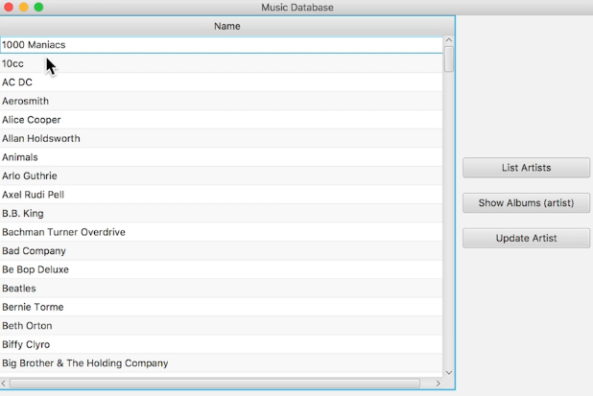  
* At this point you now know how to perform a potentially long running query and bind the results to a table.  
* Let’s now implement the showAlbums().  
* Right now the queryAlbumsForArtist() does an INNER JOIN. We could use it but since we know what the artist ID is, let’s use that instead. And that’s because querying based on an integer and without using a JOIN will actually be much quicker. And that could make a significant difference, especially if you’re dealing with large data sets. We’ll still use a PreparedStatement and since the user can’t tell us how to sort it, we’ll always display the results sorted in ASC.  
* When it comes to sorting, we may want the results returned sorted as we do, or alternatively we may want the application to sort them.  
* Let’s add the constant:  
  
* Let’s add a PreparedStatement:  
  
* Let’s initialize it in the open() method:  
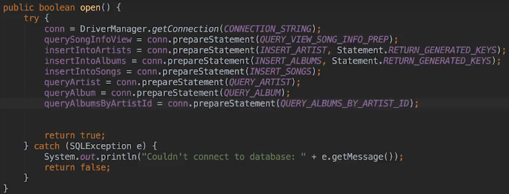  
* And in the close() method:  
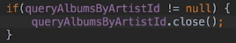

**Implement Artist Query**  
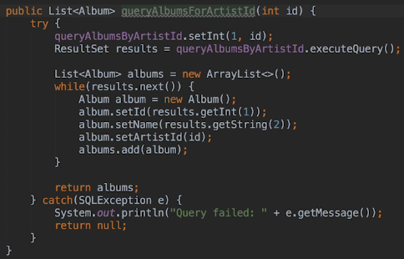  
* Now we need to display those albums.  
* We’re going to reuse the existing table to do this and only display the album name.  
* Now fortunately the Artist class stores the artist name in a variable called name. And the album also uses name so it’s the same for both.  
=> **The reason I’m mentioning that is that the Data Binding will work for both types of data**.  
* This is probably a bit of a hack so we wouldn’t really do this in a real-world application. We’d probably get around that by having multiple tables, each on a tab or perhaps have multiple tables but only one visible at a time. Another way of doing it could be to use a combo box like the SQL Browser Application does and display the selected table.  
* But since this isn’t a UI lecture, we’re going to go down the easiest route.  
* We could refactor the FX ID and the artist table variable names but we’re going to leave them as they are.  
* What we do need though is an Event Handler.  
=> We can use an anonymous Task this time because we only want to call it when the user clicks the button.  
* We need to add the onAction property to the Button.   


* We need to change the Album class the same way we changed the Artist class:  
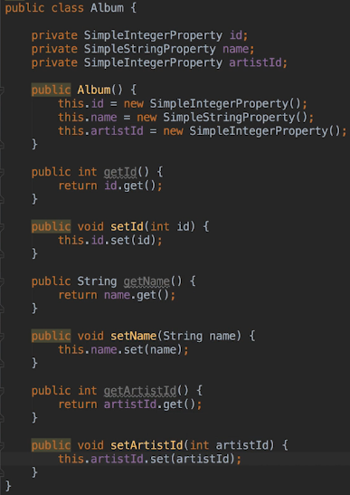  
* Now let’s create the actual method:  
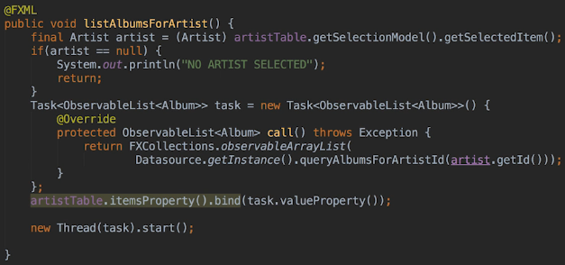  
* To get around the fact we specified the TableView for an Artist, we can change:  
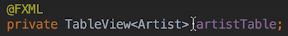  
to:  
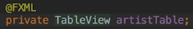  
* So we’re just basically being a bit more generic with what we’re saying the TableView contains.  
* Since both Artists and Albums use `name`, it will now work.  
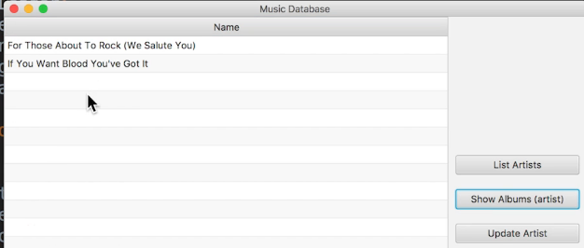

**Add ProgressBar**  
* We haven’t implemented the List Artists button yet. We need to assign an Event Handler to the Button.  
* **What we can do is use the same method we call from Application start()**.  
* We’re going to add the @FXML, that won’t affect it running from the main method at the start. But it will allow us to use that as an Event Handler for a Button.  
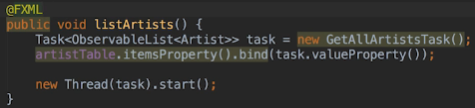  
  
* Now the button for artists works.  
* One thing we haven’t talked much about is what happens if we haven’t selected an Artist in the table and we clicked on “Show Albums”  
=> In the console we get:  
  
* Alright so it’s a bit of a hack what we’ve done here by using the same table for different data but as you can see we’ve managed to get it to work.  
* **This would probably be the sort of thing you would do as a developer while prototyping**.  
* Now let’s make the progress bar work.  
* We used an Indeterminate progress bar because we fetched the records using 1 query and we don’t know how many records there are. Even if we queried the count, we still couldn’t report progress and that’s because we get the records back all at once rather than individually.  
* Another way of doing it would be to query the records in blocks (1-100 then 101-200 etc.) and report progress between each query but that’s probably outisde of the scope of this section.  
* In FXML:  
  
* In Controller:  
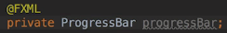  
* When we’re fetching data from the database, we need to make the progress bar visible and when that task completes, we need to make it invisible.

* Let’s implement this for the getAllArtistsTask.  
* Keep in mind that we can’t set the visibility from inside the call() method because any code that touches a UI Controller has to run on the UI Thread.  
* We also have to bind the progress bar to the task.  
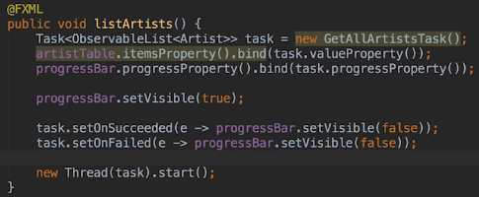  
* There are other setOn() methods in the Task class, for example we could set code to run if the Task is canceled, perhaps due to user action. But in this case we only need to worry about the success and failure cases for this demo application.  
* The call to the database is so fast that we won’t really see the progress bar, so we can test it by sleeping the Thread in queryArtists() method for example.  
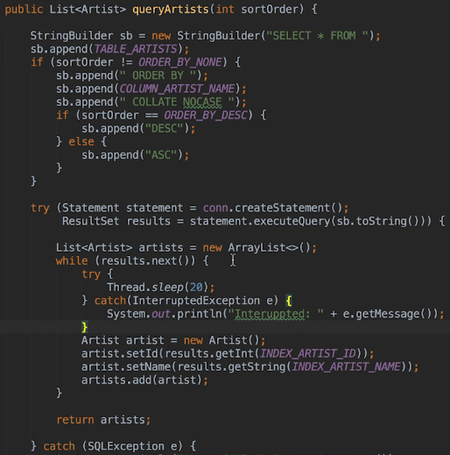  
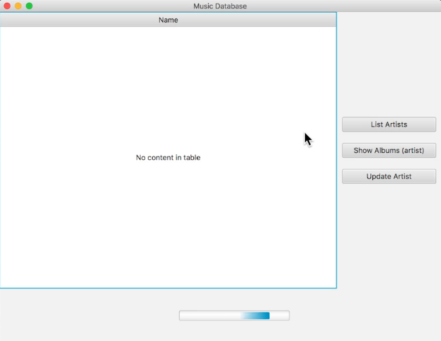

=> The important thing to remember is that we always want to run the query on a background Thread, using something like a Task.  
=> When we’re ready to update the user interface, we have to do so on the JavaFX Application UI Thread.  
=> When we’re using Data Binding, the UI code will run on the UI Thread automatically. If not, you’d want to use Platform.**runLater()** or a method like Task.**setOnSucceeded()** to run the UI code on the UI Thread.  
* Next, let’s start having a bit of a discussion about INSERTs, UPDATEs and DELETEs and specifically how to update the UI when dealing with those.

**Handling Updates**  
* How about INSERTs, UPDATEs and DELETEs of data?  
* **We handle them the same way but the question is HOW and WHEN do we updated the UI**?  
* We want to keep the database and the UI in sync.  
* There are a couple of ways to do this.  
* This is one area where it will depend on the databases and application you’re working on.  
1) => re-query the database after every successful INSERT / UPDATE / DELETE and when working with a small data set like the artists table, that’s okay but for larger data sets it may not make sense.  
2) => perform the database operation and then manually update the UI. We wouldn’t re-query the database, in our case, when doing an INSERT, we get the list the TableView is displaying and add the new artist record. And because we’re using Data Binding, when we add the new record to the list, it will then automatically be displayed in the table. For UPDATE we get the list the TableView is displaying, find the record and update the field. Once again, because of Data Binding, the change will be reflected in the table. For DELETE it’s same as for INSERT except we delete the record.  
So we’ll update the UI after the database operation has successfully completed. If something is going to go wrong, it’s more likely that the database operation will fail. So we don’t want to update the UI first because if the database operation fails, the UI will be out of sync with the database. But if the database operation succeeds but for some reason the UI update fails, that’s not really as bad. The user won’t see the change but most likely there will be a refresh button, either in our application or the browser they’re using if they’re using a web application. Worst case though, they’d have to manually refresh the data to see the change. Just as we sometimes have to do that when using the SQLite Browser.  
* How does that all translate to code?  
=> **We would run the INSERT/UPDATE/DELETE using a Task and then we would run the UI update using the Task.setOnSucceeded() method**.  
* To avoid having to code a dialogue box, we’re gonna assume that the user wants to change the name of AC DC to AC/DC. We’re going to assume the user pressed the button called update, we’ve displayed a dialogue box showing the current name of the selected list and then typed in AC/DC and pressed the okay button.  
* Because we have the selected artist, we know what the artist ID is and we’d use it to update the appropriate record in the database. And we’d then update the selected artist record and the table would update.  
  
  
  
* In open():  


* In close():  
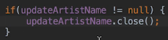  
* Let’s write the method:  
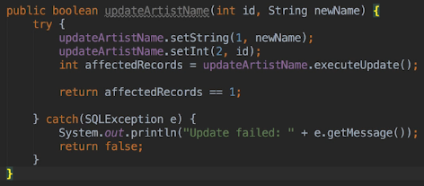  
* In Controller:  
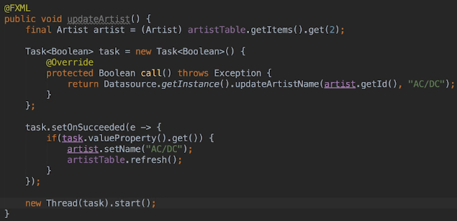  
* Normally we would do:  
  
=> The reason we’re doing it differently is we’re simulating this to avoid having to create a dialogue that accepts a new name.  
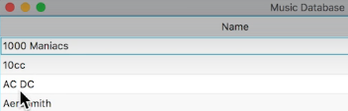  
* The Task returns a boolean because the updateArtistName returns a boolean.  
* We shouldn’t have to manually refresh() the table, but there is a bug in the current version of JavaFX when it comes to TableViews and ObservableLists. The TableView is not always noticing when an element in the list changes. The refresh() method was only added in Java 8U60 perhaps in response to this bug. The documentation states that the refresh() method is useful in cases where the underlying data sources change in a way that’s not observed by the TableView itself.  
* The refresh() method forces the TableView to re-draw its visible area. It won’t re-draw rows that are off the screen but since those will re-draw if the user scrolls to them, it doesn’t matter in our case.  
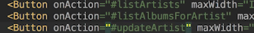  
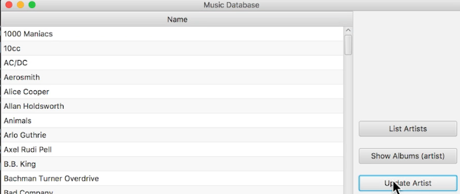

**Resources**  
SQLite Autoincrement  
<https://www.sqlite.org/autoinc.html>  
Bit Bucket  
<https://bitbucket.org/xerial/sqlite-jdbc/src/default/>  
DB Browser for SQLite  
<https://sqlitebrowser.org/>  
Interface ResultSetMetaData  
<https://docs.oracle.com/javase/8/docs/api/java/sql/ResultSetMetaData.html>